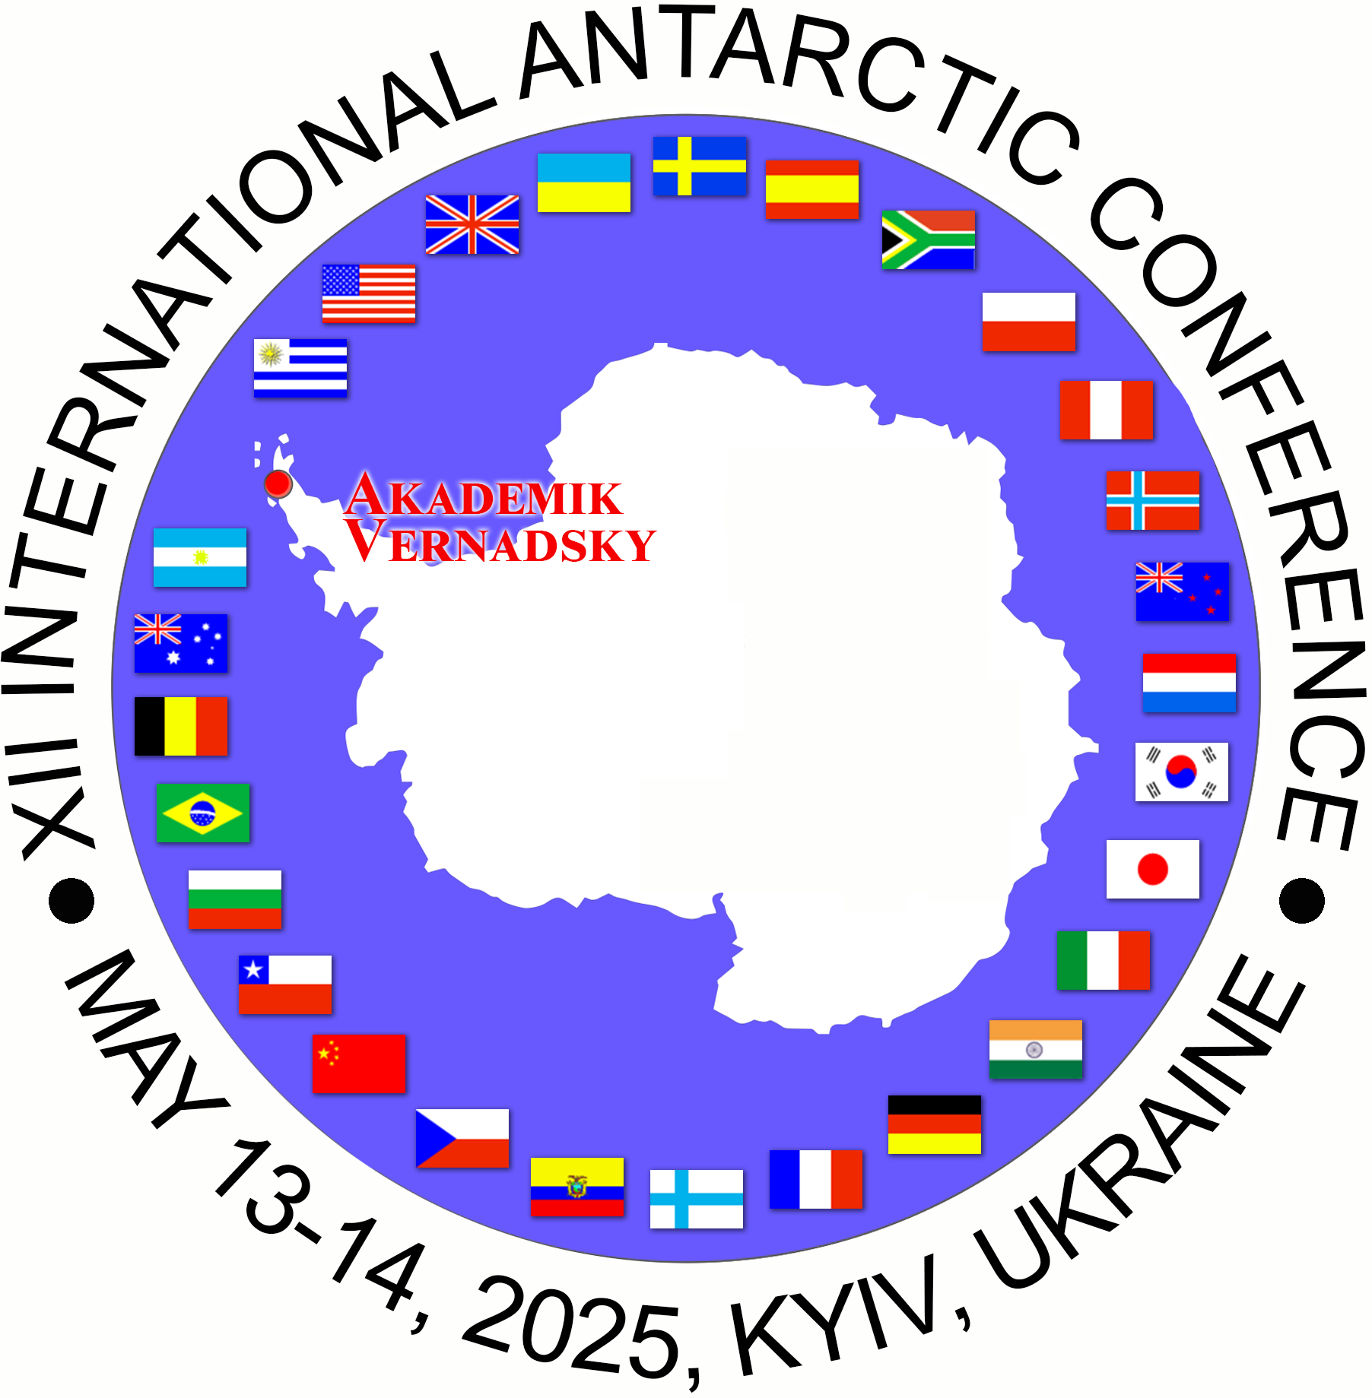 |  | XI International Antarctic Conference  “Antarctica at the cutting edge of planetary change”.  May 13–14, 2025  Kyiv, Ukraine  ХI Міжнародна Антарктична конференція «Антарктика на вістрі планетарних змін»  м. Київ, Україна  13-14 травня 2025 р.
May 13, 2025 Tuesday
10.00 – 18.20 UTC
(Kyiv Time UT+3h)
National Antarctic Scientific Center is inviting you to a scheduled Zoom meeting.

Join Zoom Meeting
https://us05web.zoom.us/j/85664645232?pwd=cquPyf3gjxvvxVGakWkgjn78G69Ma5.1

Meeting ID: 856 6464 5232
Passcode: 2Zu8FZ

09:45-  10:00 | Welcome and roll call
OPENING. WELCOME ADDRESSES
Chair: Andrii Fedchuk

10:00-  10:05 | Dr Еvgen Dykyi  Director of the State Institution National Antarctic Scientific Center, Ministry of Education and Science of Ukraine
10:05-  10:10 | Mr Arief M. Basalamah  Ambassador of the Republic of Indonesia to Ukraine
10:10-  10:15 | Dr. Kevin Hughes  Environmental Research and Monitoring Manager, the British Antarctic Survey (Cambridge, the UK)
10:15-
10:20

10:20 – 18:20 Continuation of the work of the Conference in Sections

