Attachment A:

Antarctic Specially Protected Area prior assessment template for a proposed multi-site ASPA within the Argentine Islands and Kyiv Peninsula area, Antarctic Peninsula

1 | Name of potential Antarctic Specially Protected Area (ASPA):
 | Argentine Islands and Kyiv Peninsula Region
2 | Proponent(s) of potential ASPA:
 | Ukraine
3 | Location and approximate co-ordinates of potential ASPA:
Potential ASPA includes most of the Wilhelm Archipelago and a number of coastline sites on Kyiv Peninsula, Graham Coast, mostly areas without snow cover in summer. The total extent of the borders from north to south is approx. 60 km, from west to east – approx.30 km. From the west the ASPA is bounded by the Cruls and Roca Islands. The northernmost point is Booth Island (65°2′42″S, 63°56′1″W), the southernmost is Lahille Island (65°33′26″S, 64°22′8″W).

Five sites have been identified as components of potential ASPA:
- Site 1, northern sites (map 1, 2): two small sites on Booth I., two – on Hovgaard I., three sites on Petermann I., north of Pleneau I., small sites near Girard Bay.
- Site 2, western sites (map 3): the biggest of Cruls Is., two of Roca Is.
- Site 3, eastern site (map 4, 5): Yalour Is., Cape Tuxen, Moot Point, Edge Hill, Rasmussen I. and nearby unnamed sites.
- Site 4, central site (map 6, 7, 8): Argentine Islands: Irizar I., Uruguay I., Eight I. (the biggest island between Irizar and Uruguay Islands), Galindez I., Skua I., Winter I., Corner Is., Grotto I., Three Little Pigs, the biggest of the Barchans, the biggest of the Forge Islands, the southernmost of the Shelter Islands, and Black I.
- Site 5, southern site (map 9): Berthelot Is. (partially), north of Darboux I., Cape Perez, small site near bay on Lahille I., and Mt.Waugh site.
4 | Is the potential ASPA within an existing Antarctic Specially Managed Area (ASMA)?
 | No
5 | Approximate size of potential ASPA:
 | Approximately 11 km² of terrestrial area and 0.15 km² of marine component (small sites near Galindez Island).
6 | Main physical components contained within the potential ASPA  (e.g., ice-free ground, freshwater reservoirs and streams, marine area, ice shelf, permanent ice):
 | Ice-free vegetation rich ground (oasises), permanent summer springs and pools, fresh water, and small marine areas with estimated value.
7 | Description of the initial rational for area protection for the potential ASPA:
All sites, included in the proposed ASPA, have combined values to be protected. Each site has either biodiversity or non-biological value, and each of them has on-going scientific research.
- Protection unique environmental values:
- Valuable for the Antarctic Peninsula vascular plants habitats. The vegetation in general represents a pattern of sharp discontinuities; discontinuous and only known stands of some species, the peatlands are valuable for paleoclimate reconstructions.
- The flora is among the richest, the most studied and specific in the Antarctic Peninsula region, with at least 7 liverworts, 51 mosses and 123 lichens. Highly peculiar moss banks communities and peatlands, and some of the moss banks here are up to 3800 years old. In the terrestrial vegetation communities, there also grow fungi (including some lichenicolous species) and micro- and macroalgae: 30 species of Chlorophyta, 41 diatoms and 7 cyanophytes. For both vascular Antarctic plants, Antarctic hairgrass (Deschampsia antarctica) and Antarctic pearlwort (Colobanthus quitensis), this is the middle part of one of the richest in the region vascular plants’ areas (D.antarctica and C.quitensis) from Booth Island to Garcia Point.
- Small, and therefore vulnerable and valuable populations of disjunctively distributed moss and lichen species.
- A number of mosses, lichens and invertebrates, such as tardigrads were first discovered and then described here, many of which are still known only for this region.
- The southernmost edge of the nesting range for Gentoo penguin (Pygoscelis papua) and chinstrap penguin (P.antarcticus). There are dramatic changes in this region in the context of global climate change, which result in rapid expanding of nesting area of gentoo penguins. It provides a unique opportunity to observe processes influenced by climate change. Within the proposed ASPA, there will be several sites with nesting birds combining both closed (control monitoring) and open for human access areas, which also provides a unique opportunity for real-time observations of human impact.
- Local Adelie penguin (P.adeliae) colonies are dwindling, which also requires immediate reaction. This provides a great opportunity to observe processes influenced by climate change as well.
- Two Antarctic Important Bird Areas located in the region (No 089 and 090).
- Fully viable subpopulation of the Weddell seal (Leptonychotes weddelli) from the Lemaire Channel to Lahille Island, breeding on Cruls Islands.
- The region is the southern frontier of the brown skua (Catharacta antarctica lonngbergi) nesting area, and thus this site is very important for monitoring the spread of this species.
- Marine part of the proposed ASPA is approximately 0.15 km². These are biodiversity-rich and sensitive for navigation or diving areas with giant sponges and ascidians, starfishes, ascidians, ophiuras and sea spiders, fields of gorgonian corals and others. Many intraspecific taxa of phytoplankton were found here.

- Protection scientific values and on-going/planned scientific research:
- The data archive inherited from the British Antarctic Survey, the botanical and meteorology data in particular, became the basis for further long-term plant monitoring, which have been conducted by Ukrainian researchers for more than two decades.
- Sites of the Argentine Islands Magnetic Polygon, which is the part of a magnetic observatory complex of the Akademik Vernadsky station.
- CEMP cameras installed in 2016 for annual monitoring of penguin breeding success: Yalour Islands, Galindez Island, Petermann Island.
- A geodynamic polygon, laid to monitor the Penola-Lemaire Fissure, is based on two output sites and 14 monitoring sites.
- An installed equipment for distance probing of the ionosphere that is a part of the electromagnetic research complex of the Akademik Vernadsky station on Galindez Island.
- 37 microclimate loggers for studying the microclimate and ecology of Antarctic vascular plants and further climate impact studies.
- Areas of the geologic and paleomagnetic polygons where researchers actively search for bedrocks originating from different epochs and magnetic rocks that are evidences of paleomagnetism.
- The region contains a diverse though largely unstudied invertebrate fauna, including two tardigrades that are new to science (Bryodelphax olszanowskii sp. nov. and Diphascon puchalskii sp. nov.); the copepod Pseudobocellia popeii was found here outside of its general distribution.
- Unique karyotypes of D. antarctica were found here, as well as one of the largest populations of C. quitensis in this region, which is believed to be the origin population for the whole region.
- Plots for regular studies of the dynamics of development and taxonomic structure of plankton communities (near Galindez Island).

- Protection of wilderness, geology and aesthetic values:
- The numerous rock outcrops on the Graham Coast and adjacent islands are of great interest for studying the stratigraphy, magmatism and tectonics of the Antarctic Peninsula as well as reconstruction of its geological history during the Paleozoic, Mesozoic and Cenozoic. Beside the wide range of ages, local geological formations demonstrate significant petrographic diversity of the rocks and their positioning.
- A number of geological outcrops new to the Antarctic Peninsula and important for the reconstruction of its geological history was discovered here.
- It also has high aesthetic value: Lemaire Channel, one of the most famous channels in Antarctic for its beauty and spectacular views.
- Spectacular views due to numerous islands of different heights, which are also snowy to different extent; glaciers and amazing views of high mountains of mainland in the closest vicinity.

- Protection of sites with historic value:
Although the Historic Site and Monuments are excluded from the proposed ASPA and are open for access, the area itself is of high historic value because its sites were discovered and named by Antarctic expeditions during the heroic era of Antarctic exploration. The sites excluded from proposed ASPA are: HSM №62 (Wordie House, Winter Island), HSM №27 (Port Circumcision, Petermann Island) and HSM №28 (Port Charcot, Booth Island), and all their access (landing) points remain open to visitors.

8 | Indication of the values to be protected within the potential ASPA, in accordance with Annex  V Article 3(1):
 | Value | Primary value | Secondary value | Not applicable
 | Environmental values
 | Scientific values
 | Historic values
 | Aesthetic values
 | Wilderness values
 | Combination of values
 | Ongoing or planned scientific activities
9 | Further description of values to be protected  An extended table of values of each site is given additionally as Supplement 1 in the end of the template
- Site 1 (map 1,2): northern sites (map 1, 2): two small sites on Booth I., two – on Hovgaard I., three sites on Petermann I., north of Pleneau I., small sites near Girard Bay.

These are the biggest and the highest islands of the archipelago, most of them snowy annually, with small snow-free areas in summer (some of them that are subjects to including into ASPA). Spectacular views of their high rocky and snowy peaks create the unique landscapes, the best of which is the most spectacular channel in the Antarctic Peninsula – Lemaire Channel. The site is an important area for on-going terrestrial biological and ecological research because it is a southernmost range for chinstrap penguins nesting here, and a place of nesting of several gentoo penguin colonies. Moreover, imperial shags (Important Bird Area №089 on Petermann I. and a colony on Pleneau Island), skuas and kelp gulls are breeding on these sites; Petermann Island is also a place where the southern giant petrel (Macronectes giganteus) hunts, and it is one of only three islands in the region where Adelie penguin is breeding, and one of only two sites in the region where brown skua nests. Both vascular plants are here on the northern border of their distribution in the area of Booth Island-Port Charcot. Booth Island is a place of first discovery of a D.antarctica by J. Turquet, the botanist of the Charcot 1904-1907 expedition. There is also a unique population of pearlwort almost without hairgrass, near a fairly large colony of kelp gulls. This area is a habitat for numerous mosses, rare in the region: Andreaea depressinervis, Hymenoloma crispulum, Schistidium antarctici, Bryum pallescens etc. grow on these islands. Warnstorfia sarmentosa, rare in the region, grows on Booth Island. Ecological and biological studies of these species are supported by three microclimate loggers (two on Petermann Islands and one on Booth Island) and three CEMP cameras, installed here in 2016. Snowy sheathbill (Chionis alba) is known to breed on Moot Point. These sites contain geological features of special interest to scientific research, especially granodiorite expositions, granite veins in gabbro, chrisocole inclusions, mafic dikes. Non-biological studies are supported by three tectonomagnetic and six geodynamic polygons.

Site 2 (map 3): the biggest of the Cruls Is., two of the Roca Is.

These islands are an example of a small but unique terrestrial biota of low islands composed of rocks of the Andean Intrusive Suite (Upper Cretaceous - early Tertiary - intrusive rocks), and of high wilderness and aesthetic value. The biggest islands are also home to large patches of crustose lichens and Antarctic endemic lichen Lecania brialmontii. Locator Island is a permanent habitat for the sporadically distributed Boeckella poppei. The biggest of the Cruls Islands is home to the region's largest cluster of resting Weddell seals and numerous fur seals; these islands sometimes shelter over a hundred of Weddell seals.
Another value of this sub-region of the proposed ASPA is its geology, such as numerous granodiorite expositions (with olivine gabbro, not layered like on Berthelot Islands) on Roca Islands. New occurrences of wolfram, copper, zinc and lead have been discovered in a lamprophyric dike on Roca Islands, as well as occurrences of cobalt and copper on Cruls Islands.

Site 3 (map 4,5): Yalour Is., Cape Tuxen, Moot Point, Edge Hill, Rasmussen I. and unnamed sites.
These eastern sites represent a set of locations that varies from areas, newly settled after being liberated from ice (Moot Point), to the richest continental sites in the region (Cape Tuxen etc). Cape Tuxen has one of the richest vegetation points in the proposed ASPA region. It combines the biggest area of moss banks in the region, diverse bryophyte flora and spreading gentoo colony. Two new populations of rare in the region Colobanthus quitensis were found here. Also, some bryophyte species were described from this place for first time. Rich rock bryophyte flora occurs also on Edge Hill, and the rare in the region peatland of Warnstorfia fontinaliopsis with watertable was first described from the Rasmussen oasis. Besides that, locally rare Warnstorfia sarmentosa grows in the Rasmussen Point. Rasmussen site is a unique place where dwindling of the community with Deschampsia antarctica in favor of the Moss turf subformation was found. Rasmussen Point is an important monitoring site of a growing colony of gentoo penguins. Moot Point is very interesting for studying the rates of colonization of the de-glaciated surface by different vegetation types such as the crustose lichen formations.
Yalour Islands is a unique group, its largest island is an example of the most nitrophile conditions for the growth and dominance of nitrophile lichens, and the very limited distribution of nitrophobe fruticose lichens. The islands are home to the second (of three) colony of Adelie penguin in the region, and to brown skua, a species that is on its southernmost edge of a nesting range and is very rare in the region. To support a study of Adelie penguin breeding success, CEMP cameras were installed on the biggest of the Yalour Islands. Besides that, a few imperial shags, also rare in the region, are nesting on a smaller Yalour Islands nearby; the southern giant petrel (Macronectes giganteus) hunts here. Snowy sheathbill (Chionis alba) is known to breed on Moot Point. Weddell seals were identified for Rasmussen Island and Cape Tuxen.
Biological studies are supported by five microclimate loggers. Non-biological studies are supported by five tectonomagnetic and three geodynamic polygons.

Site 4 (map 6,7,8): Argentine Islands: Irizar I., Uruguay I., Eight I., Galindez I., Skua I., Winter I., Corner Is., Grotto I., Three Little Pigs, the biggest of the Barchans and the Forge Islands, the southernmost of Shelter Islands, and Black I.

The Barchans and Forge Islands
Islands on which the border of Andean Intrusive Suite and Antarctic Peninsula Volcanic Group passes. Forge Islands and Barchans are not rich in vegetation (with single site of D.antarctica stable form in 1970th (monitoring site), but valuable for other values. These are rocky islands, and the large population of Larus dominicanus breeds here. A population of Deschampsia antarctica, growing in one of the most extreme conditions is located here, and is known since 1970. Also, depleted and the most extended towards the open ocean communities of Polytirchum strictum grow here. These islands are also important for resting seals. It is a site valuable for geological studies: there are the Paleogene granitoids (The Barchans), and the Forge Islands containing manifestations of Fe-Mo-Cu-Fe and Th-TR ore mineralization; the manifestations of the youngest Ne-Qu mafic dyke magmatism happen on The Barchans.

Uruguay I., Eight I., Irizar I., Galindez I., Skua I., Winter I., Corner I., Grotto I., Three Little Pigs, the southernmost of Shelter Islands, and Black I.
Includes islands formed by rocks and the Antarctic Peninsula Volcanic Group; they are relative rich in vegetation. The two highest islands, Uruguay and Galindez, form the main component of the landscape of this archipelago. The Argentine Islands are of great ecological importance due to rich terrestrial vegetation including old moss banks and both vascular plants growing there. Galindez Island is unique island for the whole area, with specific and very well studied rich biodiversity. The populations of regionally rare C.quitensis were found and taken under monitoring on Irizar I., Eight I., near Uruguay I, and on Galindez Island, Skua Island and Black Island. Also, it is a habitat for many regionally rare moss species like Pohlia wahlenbergii, Cratoneuropsis relaxa and lichens (i.e., Himantormia lugubris). Uruguay Island is also the only place with pure monospecies stands of Chorisodontium aciphyllum and habitat of rare bryophyte species. Black Island and Corner Islands have very rare bryophytes, like Encalypta procera, Cratoneuropsis relaxa, Didymodon brachyphyllus etc. On the islands of this group, a freshwater crayfish Brachinecta sp. was found.
The Important Bird Area №090 for protecting imperial shag is located on Uruguay Island; sites are a nesting place for skuas and kelp gulls, and for breeding of the fur seal. However, rich vegetation of the island also need protection.
Of great importance is gentoo penguin colony on Galindez Island, formed in 2007/2008 season, as well as snowy sheathbill nesting here, which have not been found in the area of the station before. Penguin colony is constantly expanding, and is a subject to monitoring. There are 9 CEMP cameras within the proposed ASPA, and three of them are located on Galindez Island.
Large number of breeding south polar skua and kelp gull are found here, leopard seals hunting nearby. It is especially important to protect this biodiversity if we consider the fact this area is one of the most visited in the whole Wilhelm Archipelago.
This site is also one of the most important for local scientific research, including climate change studies, which is supported by numerous microclimate loggers (20) and a number of experimental plant plots. Besides, several marine research plots with rich benthos communities, already mentioned in p.7, are located near Galindez Island and also require protection as benthos here is very vulnerable to anchoring of yachts.

Site 5 (map 9): Berthelot Is. (partially), north of Darboux I., Cape Perez, small site near bay on Lahille I., and Mt.Waugh site.
This site includes monument islands with spectacular views. Although ASPA 108 (Green Island) is excluded from the proposed ASPA, Cape Perez is also vegetation-rich, as well as Darboux Island, with their valuable moss banks and both Antarctic vascular plants. Locally rare pearlwort is widespread on the biggest and the smaller of the Berthelot islands, on Lahille Island, Darboux Island and on Cape Perez. The southernmost sites of this area – Lahille Island and Mount Waugh – also have a moss that is very rare in the region: Warnstorfia sarmentosa. Locally rare moss Polytrichum juniperinum is also widespread on Lahille Island, rare liverwort Metzgeria decipiens on the biggest of Berthelot Islands. Darboux I. is a growth place of rare moses like Bryum pallescens, Encalypta procera , Didymodon brachyphyllus etc. and biggest specimens of Umbilicaria antarctica spread, and Cape Perez – for Schistidium rivulare, Tortella fragilis, Orthotrichum rupestre etc. Freshwater pools with sporadically-distributed populations of crustaceans are located within this site. The southernmost colony of gentoo penguins, which is a subject to monitoring, is located on this site. The third of three Adelie penguin site is located within the Berthelot Islands (the smaller one to the right of the biggest of the Berthelot Islands). Many regionally rare moss species are found there. Cape Perez – the only known in the region nesting place of southern giant petrel. The biggest of the Berthelot Islands is also interesting because of its post-glacier moraines between the island’s tops, showing the presence of old glaciation.

10 | The following characteristics are contained within the potential ASPA: |  |  |  | (Yes/No)
(a) | areas kept inviolate from human interference so that future comparisons may be  possible with localities that have been affected by human activities |  |  |  | Yes
(b) | representative examples of major terrestrial, including glacial and aquatic,  ecosystems and marine ecosystems |  |  |  | Yes
(c) | areas with important or unusual assemblages of species, including major  colonies of breeding native birds or mammals |  |  |  | Yes
(d) | the type locality or only known habitat of any species |  |  |  | Yes
(e) | areas of particular interest to ongoing or planned scientific research |  |  |  | Yes
(f) | examples of outstanding geological, glaciological or geomorphological features |  |  |  | Yes
(g) | areas of outstanding aesthetic and wilderness value |  |  |  | Yes
(h) | sites or monuments of recognised historic value |  |  |  | No
(i) | such other areas as may be appropriate to protect environmental, scientific, historic, aesthetic or wilderness values, any combination of those values, or  ongoing or planned scientific research |  |  |  | No
11 | Consideration as to whether the ASPA be protected primarily for conservation or scientific research purposes:
 | Each of 7 sites can be protected both for conservation and scientific research purposes simultaneously.
11 | Description of how the quality of the areas merits ASPA designation (e.g. representativeness, diversity, distinctiveness, ecological importance, degree of interference,  science and monitoring uses):
 | The proposed ASPA is representative for the region of Wilhelm Archipelago and Graham Coast, with all variety of species and types of terrestrial ecosystems of the region; it has many unique components. Genetic variants of some species have also been discovered here. The proposed ASPA, which is accessible from Vernadsky station or research vessels, is a site for a variety of regular monitoring studies, which are often conducted in international collaboration. Together, not only it allows to achieve the main goal – conservation of this rich in biodiversity region – but also to continue valuable and diverse scientific studies (geological, environmental, meteorological etc.) for better understanding of the climate change processes and physiology of Antarctic plants and animals in a changing climate.
13 | Assessment of the risk posed to the area due to human activities and impacts, natural processes, natural variability and viability, non-Antarctic threats, urgency and scientific uncertainty:
One of the main risks for the region of the proposed ASPA is growing tourism, which can have a negative impact on marine mammals and seabirds, as well as be a threat to the further nesting of brown skua, whose range boundary is located in the proposed ASPA. In addition, the ASPA area is at the epicentre of climate change, and some processes are dramatic, in particular, the rapid expansion of gentoo penguins, which changes the picture of local ecosystems.

The tourist impact may be a threat on the islands with developed moss vegetation and foliose or fruticose lichen vegetation, as tourists trample vulnerable vegetation. Both the marine and terrestrial component of the proposed ASPA is vulnerable to yachts and its tourists. Disembarking tourists have an impact to all terrestrial territories, except of ASPA and tourist-restricted areas. Marine ecosystems in waters near Galindez Island should be protected because anchors of yachts destroy underwater benthic biodiversity.

Designation of the protected area within a systematic environmental-geographical framework:
14 | The area lies within the following Environmental Domains Analysis region(s) (Resolution 3  (2008)):
 | Environment Domain B and E.
15 | The area lies within the following Antarctic Conservation Biogeographic Region (Resolution 6  (2012)):
 | Region 3 – North-west Antarctic Peninsula
16 | The area contains the following Antarctic Important Bird Areas (Resolution 5 (2015)):
 | №089 (Petermann Island) and №090 (Uruguay Island)
17 | Short description of how the potential ASPA has been considered to improve the  representativeness of the protected areas network:
 | The proposed ASPA is not a single non-viable ecosystem fragment; it represents an entire ecosystem of the region with all its rich biodiversity and unique communities. Besides, the geographical position of the potential ASPA, its climate and rich biodiversity allow comprehensive study of a complex of environmental processes and parameters in central part of Western Antarctic Peninsula.
18 | Other relevant information from the assessment process:
 | None
19 | Any relevant supporting documentation
 | See Map 1 and list of scientific publications resulting from research on Anchorage Island (below)

Publications resulting from international research on the Argentine Islands, the Wilhelm Archipelago
- Casanovas, P., et al. (2015) “A comprehensive coastal seabird survey maps out the front lines of ecological change on the western Antarctic Peninsula,” Polar Biology, 38(7), pp. 927–940. Available at: http://doi:10.1007/s00300-015-1651-x
- Dykyy, І. V., et al. “Features of Chronology and Breeding Success of Pygoscelis Papua and P. Аdeliae (Spheniscidae) Penguins in the Wilhelm Archipelago (CCAMLR Subarea 48.1).” Ukrainian Antarctic Journal, no. 1(17), pp. 130–47. Available at: https://doi.org/10.33275/1727-7485.1(17).2018.39
- Dykyy, I. V., et al. (2013) “The effect of anomal season of Antarctic summer on the reproduction of Gentoo penguins (Pygoscelis papua) near Akademik Vernadsky station,” Internationalization of Antarctic research – way to spiritual unity of humanity: abstracts VI International Antarctic Conference (Kyiv, 15–17 May 2013), pp. 59–63.
- Fowbert, J. A. and Smith, R.I.L. (1994) “Rapid population increases in native vascular plants in the Argentine Islands, Antarctic Peninsula,” Arctic and Alpine Research, (26), pp. 290—296.
- Gremmen, N.J.M. et al. (1994) “Epilithic macrolichen vegetation of the Argentine Islands, Antarctic Peninsula,” Antarctic Science, 6(4), pp. 463—471.
- Ivanets, V. et al. (2022) “Skua and Plant Dispersal: Lessons from the Argentine Islands – Kyiv Peninsula region in the Maritime Antarctic,” Nordic Journal of Botany, 2022(6). Available at: https://doi.org/10.1111/njb.03326
- Ivanets, V. et al. (2023) “Range extensions for Moss species on the west side of the Antarctic Peninsula,” Cryptogamie, Bryologie, 44(2). Available at: https://doi.org/10.5252/cryptogamie-bryologie2023v44a2
- Kaczmarek, U., et al. (2020) “New Records of Antarctic Tardigrada with Comments on Interpopulation Variability of the Paramacrobiotus fairbanksi Schill, Förster, Dandekar and Wolf, 2010.” Diversity, 12(3), p.108. https://doi.org/10.3390/d12030108
- Komplikevych, S. et al. (2022) “Culturable microorganisms of substrates of terrestrial plant communities of the Maritime Antarctic (galindez island, Booth Island),” Polar Biology, 46(1), pp. 1–19. Available at: https://doi.org/10.1007/s00300-022-03103-7
- Kondratyuk, S.Y. et al. (2022) “New and noteworthy lichen-forming and lichenicolous fungi, 12,” Acta Botanica Hungarica, 64(3-4), pp. 337–368. Available at: https://doi.org/10.1556/034.64.2022.3-4.8
- Kovalenko, P. et al. (2022) “Current status of Belgica antarctica Jacobs, 1900 (Diptera: Chironomidae) distribution by the data of Ukrainian Antarctic Expeditions,” Ukrainian Antarctic Journal, (2), pp.76—93. Available at: https://doi.org/10.1556/034.64.2022.3-4.8
- Lynch, H.J., Naveen, R. & Casanovas, P.V. (2013) “Antarctic Site Inventory breeding bird survey data 1994 – 2013,” Ecology, 94(11). Available at: https://doi.org/10.1890/13-1108.1
- Mytrokhyn, O. et al. (2021) “Intrusive-magmatic complexes of Wilhelm Archipelago, West Antarctica (Part 1 – Intrusions of Gabroids, Diorites and Granitoids),” Visnyk of Taras Shevchenko National University of Kyiv. Geology, 4(95), pp.6–15. Available at: https://doi.org/10.17721/1728-2713.95.01
- Mytrokhyn, O. V. and V. G. Bakhmutov (2021) “First Finding of the Orbicular Gabbroids in the Ukrainian Antarctic Station Area (Wilhelm Archipelago, West Antarctica),” Mineralogical Journal, 43(2), pp. 40–48. Available at: https://doi.org/10.15407/mineraljournal.43.02.040.
- Mytrokhyn, O., et al. (2022) “Intrusive-magmatic complexes of Wilhelm Archipelago, West Antarctica (Part 2 – Hypabyssal and Subvolcanic Dyke Rocks),” Visnyk of Taras Shevchenko National University of Kyiv. Geology, 3(98), pp. 5–14. Available at: https://doi.org/10.17721/1728-2713.98.01
- Ochyra, R, Smith, R.I.L., Bednarek-Ochyra, H. (2008). The illustrated moss flora of Antarctica. Cambridge University Press, Cambridge.
- Parnikoza, I. et al. (2019) “Complex Survey of the Argentine Islands and Galindez Island (Maritime Antarctic) as a Research Area for Studying the Dynamics of Terrestrial Vegetation.” Ukrainian Antarctic Journal, 1(17), pp.73–101. Available at: https://doi.org/10.33275/1727-7485.1(17).2018.34
- Parnikoza, I., Dykyy, I., Ivanets, V., Kozeretska, I., Kunakh, V., Rozhok, A., Ochyra, R., Convey, P. 2012. Use of Deschampsia antarctica for nest building by the kelp gull in the Argentine Island area (maritime Antarctica). Polar Biology, 35(11), 1753—1758. Available at: https://doi.org/10.1007/s00300- 012-1212-5
- Parnikoza, I., et al. (2009) “Current Status of the Antarctic herb tundra formation in the Central Argentine Island,” Global Change Biology, (15), pp. 1685-1693. Available at: https://doi.org/10.1111/j.1365-2486.2009. 01906.x
- Polishchuk, A. et al. (2023) “New records of tardigrades from the Danco and Graham coasts, the Maritime Antarctic,” Annales Zoologici, 73(1). Available at: https://doi.org/10.3161/00034541anz2023.73.1.002
- Polishuk, V., et al. (2009) “The complex studying of Antarctic biota,” Ukrainian Antarctic Journal, (8), pp. 293—301.
- Rabokon, A. et al. (2020) “Assessment of Colobanthus quitensis genetic polymorphism from the Argentine Islands Region (maritime antarctic) by actin, α- and γ-tubulin genes intron analysis,” Ukrainian Antarctic Journal, (1), pp. 93–101. Available at: https://doi.org/10.33275/1727-7485.1.2020.382
- Smith, R.I.L, Corner, R.W.M. (1973) “Vegetation of the Arthur Harbour-Argentine Islands Region of the Antarctic Peninsula,” British Antarctic Survey Bulletin, (33—34), pp. 89—122.
- Wierzgon, M. et al. (2023) “Moss Bank composition on the Galindez Island (Argentine Islands): What it signifies?” Available at: https://doi.org/10.21203/rs.3.rs-2743635/v1 (prepint).
- Yerkhova, A. et al. (2022) “Microbiomes of antarctic pearlwort (Colobanthus quitensis) of the maritime antarctic: Distinct diversity and core microbes in rhizosphere and endosphere compartments of the plant,” Ukrainian Antarctic Journal, 20(2). Available at: https://doi.org/10.33275/1727-7485.2.2022.701
- Yevchun, H. et al. (2021) “Minimizing tourist impact on the Argentine Islands Ecosystem, Antarctic Peninsula, using visitor site guidelines approach,” Ukrainian Antarctic Journal, (1), pp. 98–116. Available at: https://doi.org/10.33275/1727-7485.1.2021.669
- Yevchun, H. et al. (2021) “The toponymy of the Argentine Islands area, the Kyiv Peninsula (West Antarctica),” Ukrainian Antarctic Journal, (2), pp. 127–157. Available at: https://doi.org/10.33275/1727-7485.2.2021.683

Supplement 1

 |  | Values to be protected
 |  | Environmental |  |  |  |  |  | Scientific |  | Wilderness | Aesthetic
 |  | Vegetation¹ | Vascular plants² | Rare or unique species⁴ | Avifauna² | Marine mammals³ | Terrestrial biological communities | Research | Environmen-tal monitoring control area
Northern Site | Booth Island (north) | ** | ** | * | *** |  |  | * | * | * | *
 | Mainland sites | * | ** | * | ** |  |  | * | * |  | *
 | Pleaneau Island (north) | * | * | * | ***** | ** |  |  |  | *
 | Hovgaard Island | * | ** | * | *** |  |  | * | * | * | *
 | Petermann Island | **** | ** | * | ***** | * | * | * | *
West.site | Biggest of the Cruls Islands |  |  | * | * | ** |  |  |  | * | *
 | Roca Islands |  |  |  |  | * |  | * |  | *
Eastern Site | Yalour Islands | ** | * | * | **** |  | * | * | *
 | Cape Tuxen | ***** | ** | * | **** | * | * | * | * | * | *
 | Moot Point | ** |  | * | * |  | * | * | * | *
 | Edge Hill | ***** | * | * |  |  | * |  |  |  | *
 | Point near Rasmussen I. ("Rasmussen Oasis") | ***** | * | * | * |  | * | *
 | Rasmussen Island | ** | * |  | *** | * | * | * |  |  | *
Central site (Argentine Islands) | The Barchans (the biggest island) | * | * |  | *** | ** | * | * | * | * | *
 | Forge Islands (the biggest north island) | * |  | * | ** | ** | * |  |  | *
 | Three Little Pigs | ** |  |  | ** | ** | * |  | *
 | eastern Shelter Is. | ** |  |  |  | * |  | * |  | * | *
 | Irizar Island | ***** | ** |  | * | * | * | *
 | Eight Island | **** | ** |  | * |  | * | * | *
 | Uruguay Island | *** | ** | * | *** | * | * | * | *
 | Galindez Island | ***** | ** | * | ***** | ** | * | * | * |  | *
 | Skua Island | **** | ** | * | *** | ** | * | * | *
 | Winter Island | * |  | * | ** |  | * |  |  | *
 | Grotto Island | * | * |  | *** |  | * | * | *
 | Corner Island | **** |  | * | ** | * | *
 | Black Island | **** | ** |  | * | * | * | * | *
Southern site | North part of the biggest Berthelot Is. | ** | ** | * | ** | * | * | * | * |  | *
 | Small island to the east |  |  | * | ** |  | * | *
 | Small islands to the south-west | * | * | *
 | North shore of Darboux Island | * | ** | * | * |  | * | * | *
 | Cape Perez | ***** | ** |  |  |  | * | * | * | * | *
 | Mt. Waugh | * | * | * |  |  |  | *
 | Lahille I., small site near southwest bay | * | ** | * |  |  |  |  |  | * | *
¹ | Number of "asterics" reflects richness of vegetation cover, both lichen and moss, including moss banks.
² | Number of "asterics" reflects a number of species.
³ | Number of "asterics" reflects a number of marine mammal species, both breeding and resting in the region.
⁴ | Number of "asterics" means the presence of relevant feature.

Overall map of a proposed multi-site ASPA within the Argentine Islands and
Kyiv Peninsula area, Antarctic Peninsula

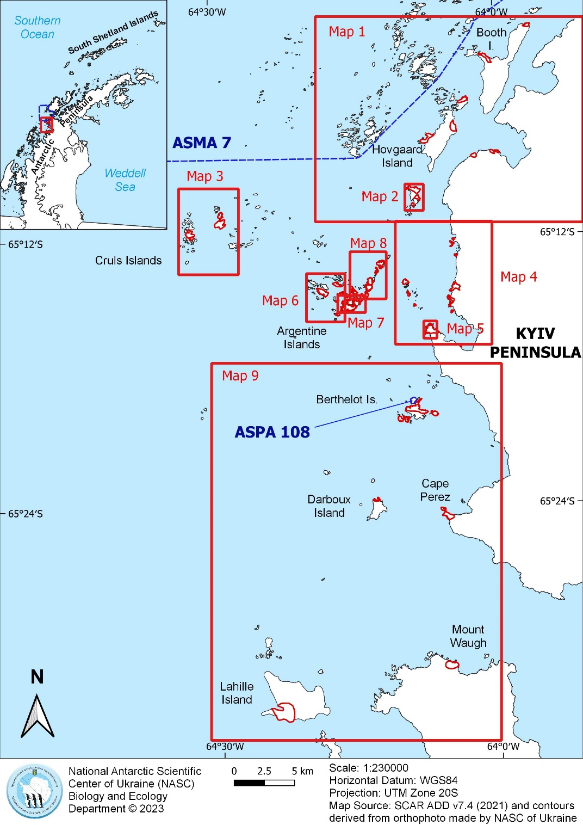

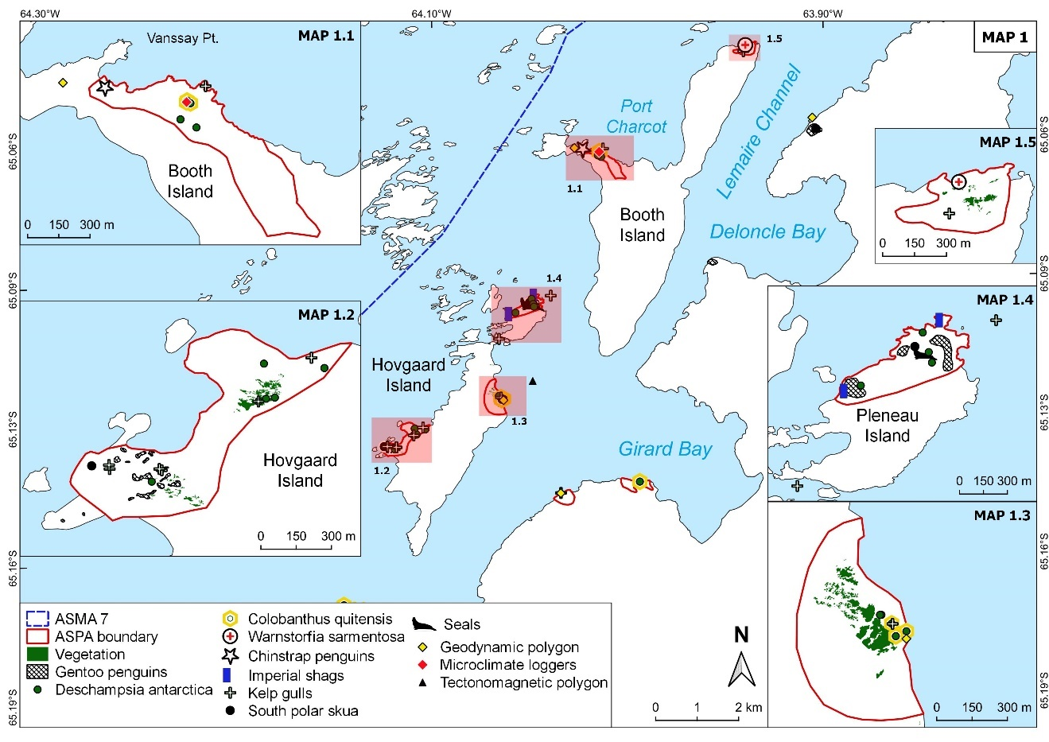
Map 1. Booth Island, Hovgaard Island, and Pleneau Island

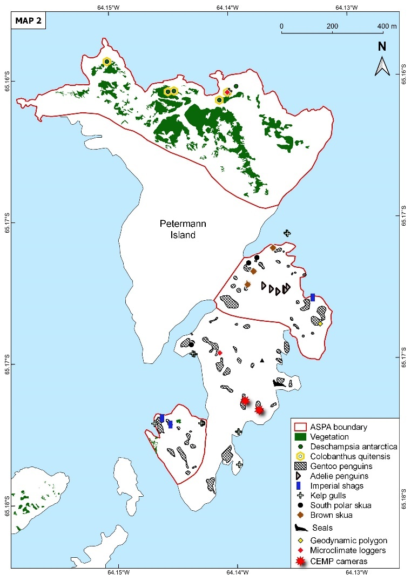
Map 2. Petermann Island

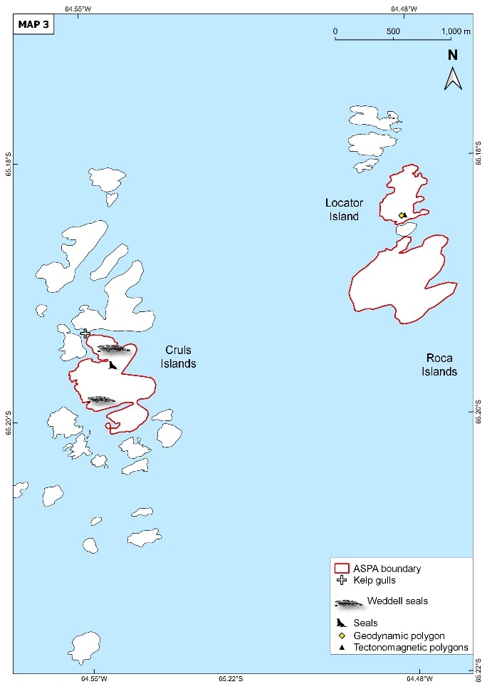
Map 3. Cruls and Roca Islands

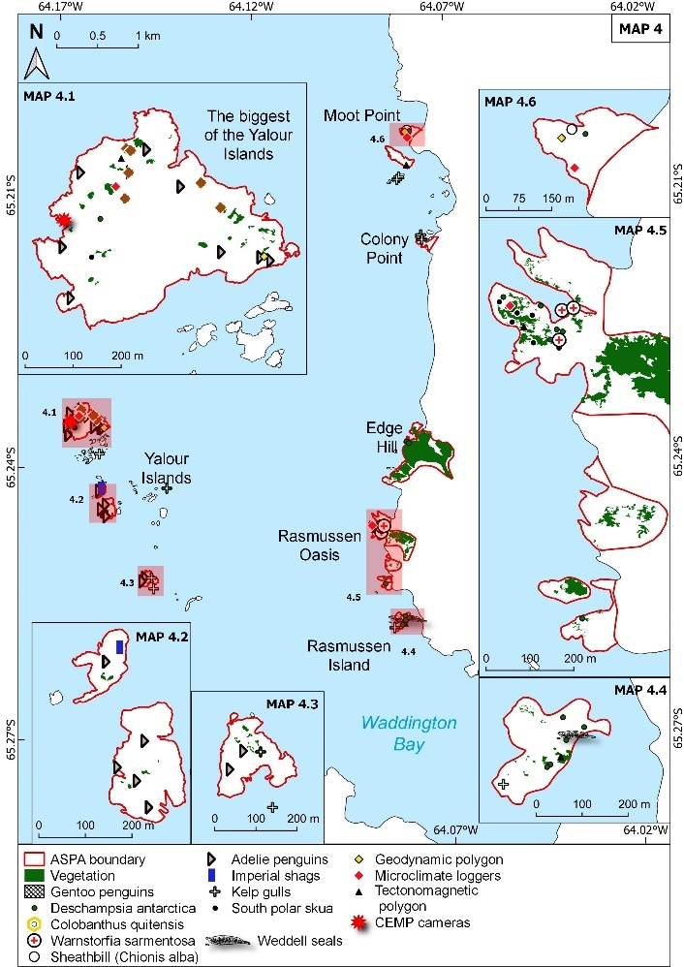
Map 4. Yalour Islands and Kyiv Peninsula (west)

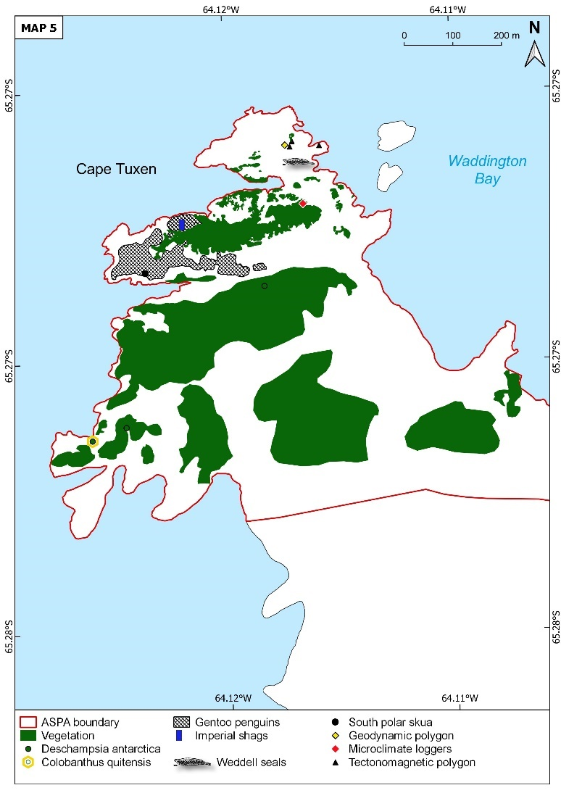
Map 5. Cape Tuxen, Kyiv Peninsula

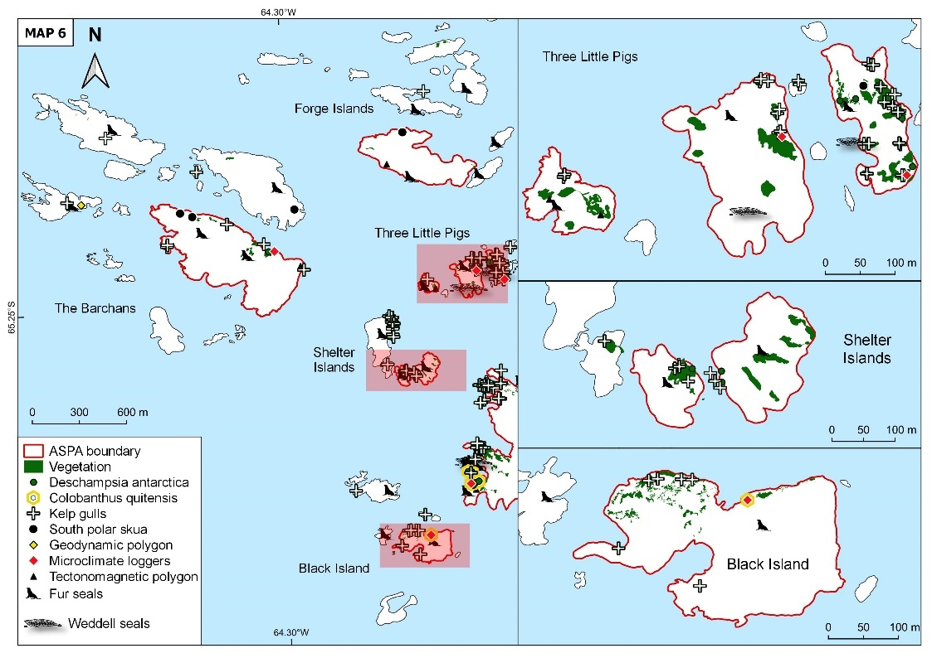
Map 6. The Barchans Islands, Forge Islands, Three Little Islands, Shelter Islands, and Black Island (within the Argentine Islands)

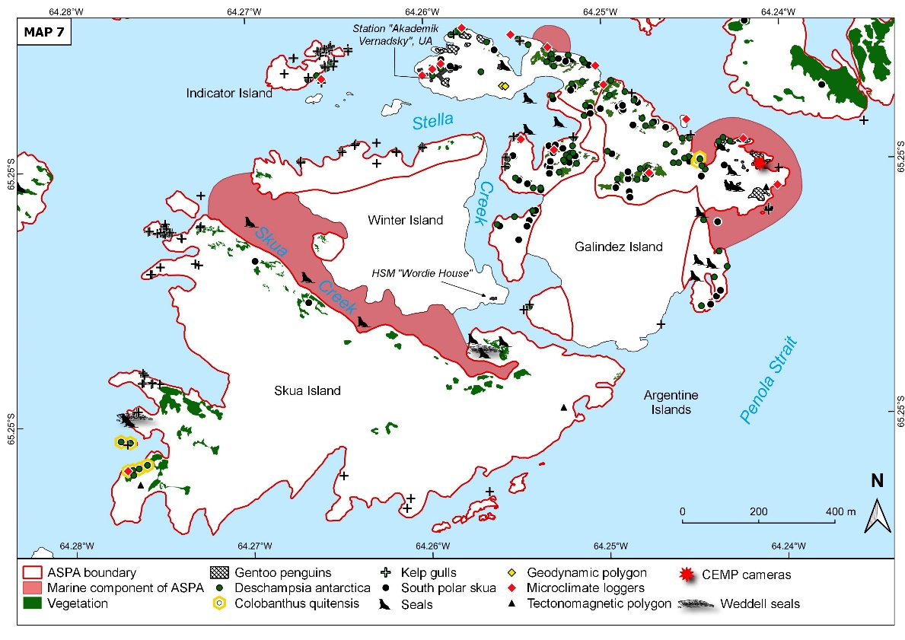
Map 7. Galindez Island, Winter Island, and Skua Island (within the Argentine Islands)

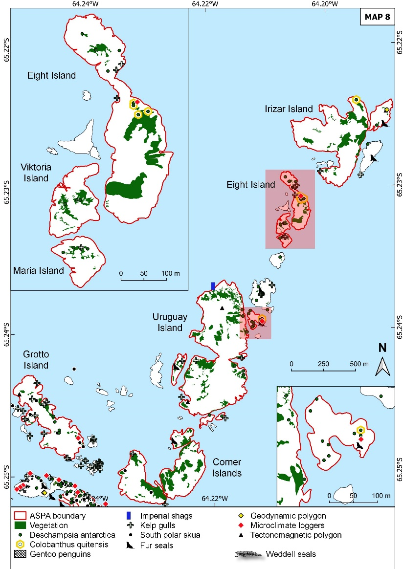
Map 8. Grotto Island, Corner Island, Uruguay Island, Eight Island, and Irizar Island (within the Argentine Islands)

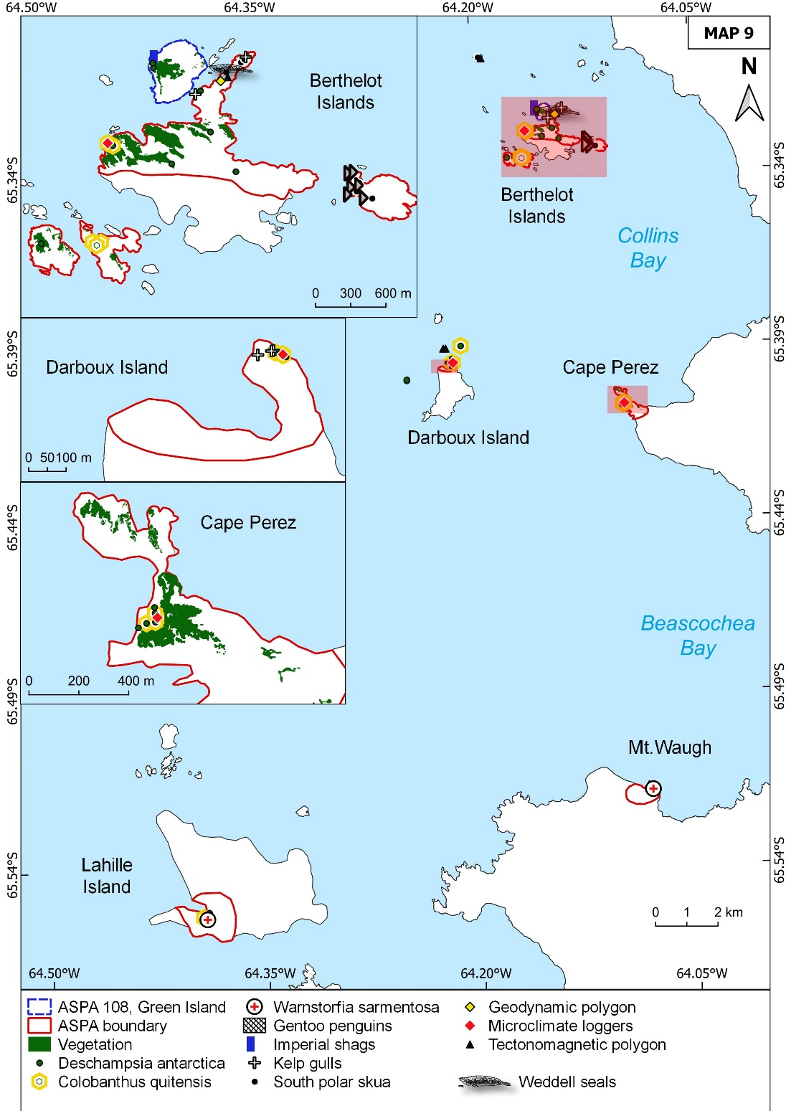

Map 9. Barthelot Islands, Darboux Island, Lahille Island, Cape Perez (Kyiv Peninsula)

