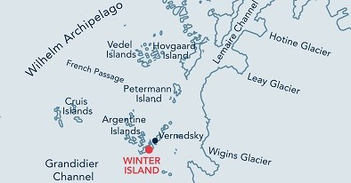
Key Features
- Historic British Base ‘F’, Wordie House
- Glacial scenery

Description

TOPOGRAPHY
Wordie House stands on a very small, flat peninsula on Winter Island (part of the Argentine Islands and composed entirely of igneous rocks). The hut is surrounded by water to the immediate south. A narrow channel called Stella Creek separates Winter Island from Galindez Island on which Ukrainian Vernadsky Station is situated. The surrounding islands protect the site from the open sea and in summer the area is relatively clear of snow. A large permanent snow bank is found to the west of the base.

FAUNA
Regularly haul out: Weddell seal.
Also present: Adélie penguin, Blue-eyed shag, Gentoo penguin, Kelp gull, South Polar Skua, Wilson’s storm-petrel.

FLORA
Rhizocarpon sp. and Usnea Antarctica lichens are present on the island. The moss Polytrichum strictum is also found.

OTHER
Base ‘F’ is designated as Historic Site and Monument No. 62 under the Antarctic Treaty, and is operated by the UK Antarctic Heritage Trust. It was built in 1947 on the site of the earlier 1936 British Graham land Expedition hut, which was swept away by a tidal wave. In addition to the building, there is also a rare timber sign which dates from 1947.

Visitor Impact

KNOWN IMPACTS
None.

POTENTIAL IMPACTS
Fire. Minor fuel spills. Wildlife disturbance.

Landing Requirements

SHIPS*
Max pax on board: 500 Ships per day: 2
Comments: Maximum 2 ships per day (midnight to midnight), of which no more than 1 can carry over 200 passengers.
* A ship is defined as a vessel which carries more than 12 passengers.

VISITORS
Maximum number of visitors at any time, exclusive of expedition guides and leaders: 36

Comments: No more than 12 visitors are allowed inside the base at any one time. Visitors enter the base at their own risk and neither the UK authorities nor National Antarctic Scientific Centre, personnel from Vernadsky Station, nor the Ukraine authorities will be liable for any personal injury or damage to property that may be sustained.

Base ‘F’ was proposed as HSM No 62 by the United Kingdom. The site is managed by the UK and the nearby Ukrainian Vernadsky Station. Visits to the hut may only take place with prior permission given by a Party. The Party undertaking management of the site should also be informed prior to the visit. The key for the hut is held by the Vernadsky Station Leader. Where practicable, expedition leaders are requested to invite at least one member of the Vernadsky staff to come aboard the vessel to brief passengers and staff prior to any visit taking place.

Visitor Area

LANDING AREA
The preferred site is on the south-east side of the island, immediately in front of the entrance to the hut. In case of emergency, helicopter landings are potentially possible at the top of the island’s ice cap.

CLOSED AREA
All areas not specifically designated for visitors’ activities are closed in order to preserve rich moss and lichen vegetation, and nesting areas.

GUIDED WALKING AREA
Visitors may conduct a guided walk on recommended route from Wordie House and nearby shore to the top of the ice cap offering glacial scenery (see the map).

FREE ROAMING AREA
None.

Visitor code of conduct

BEHAVIOUR ASHORE
- All boots and outdoor clothing should be cleaned of snow and grit before entering the building. All backpacks and large bags should be left outside the hut.
- Visitors are to leave the base safe and fully closed up on departure.
- No overnight stays in the hut are allowed. The hut is available for visitor educational visits and, except in emergency circumstances, should not be used for any other purpose.
- Artefacts should not be handled or removed from the site. Do not sit on chairs or other furniture, or lay objects down on tables or work surfaces.
- A record of each visit should be left in the Visitors Book, located in the base.
- Smoking and the use of candles, matches or stoves are prohibited in and around the hut.
- Loose gravel, mud and snow should be swept up, and floors wiped dry after each visit.
- Walk slowly and carefully. Give animals the right-of-way.

CAUTIONARY NOTES
The rocks at the landing site can be slippery when wet. Care should be taken when following the walk to the viewpoint at the top of the ice cap.

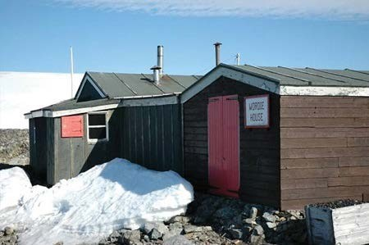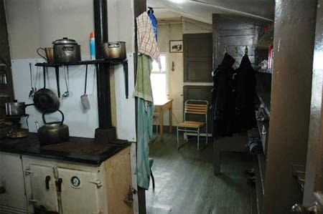
The hut seen from the south and showing the various different builds  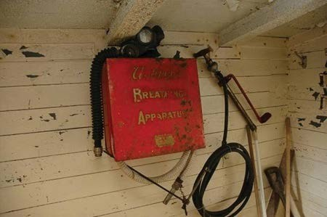  Breathing apparatus and a stirrup pump hanging on the entrance porch wall | The kitchen and the living and bunk room area beyond

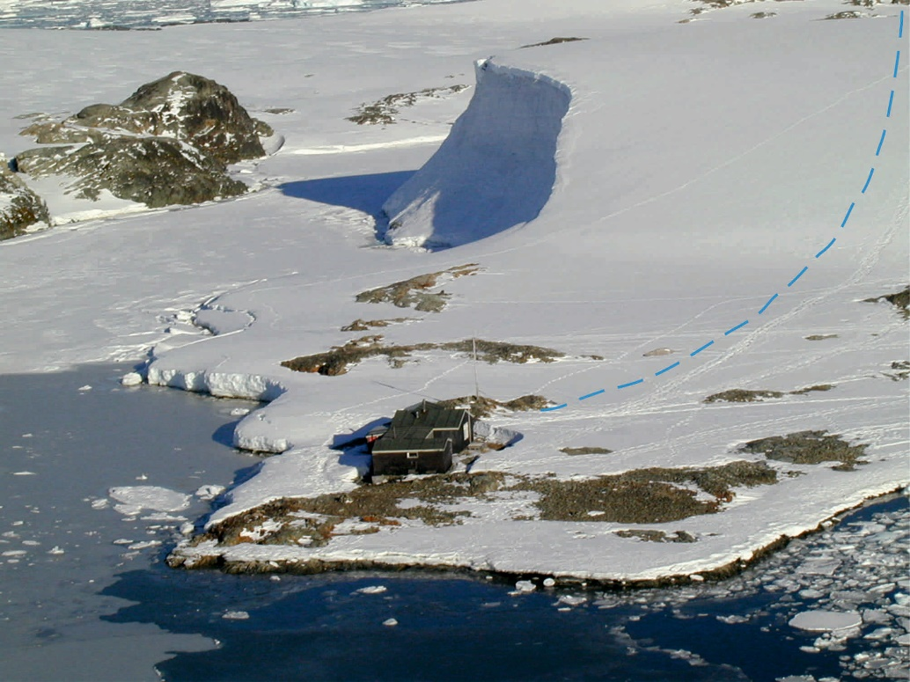
The hut seen from the east showing how close it is built to the sea (recommended visitor path to the top of the ice cap shown in the background)

