Vernadsky Station, Galindez Island

65°15' 00'' S, 64°16' 00'' W
Located in the Argentine Islands, separated from Kyiv Peninsula by Penola Strait

Key Features  - Year-round research station  - Seal species and one of the southernmost recorded gentoo penguin colonies  - Populations of both species of vascular plants growing in Antarctica, mosses banks & lichens  - Glacial scenery | 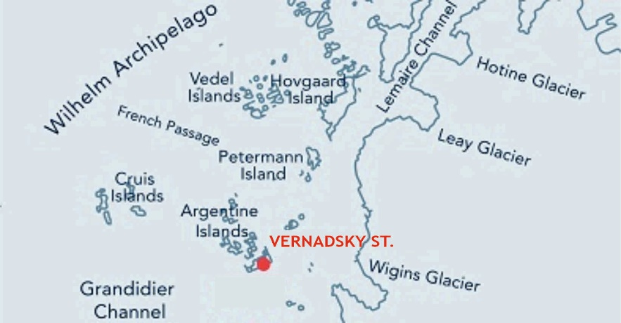

Description

TOPOGRAPHY
Year-round Vernadsky Station (operated by Ukraine) is situated on the Marina Point in the NW of Galindez Island, one of the largest islands in the Argentine Islands (along with Winter Island and Skua Island), lying 5-6 km NW of the Antarctic Peninsula (Graham Coast, Kyiv Peninsula). There are relict glaciers, post-glacier landforms such as moraines and glacier rocks, numerous rock outcrops, freshwater reservoirs and ephemeral springs on the islands, and shallow though biodiversity-rich marine creeks between them.
FAUNA
Confirmed breeders: gentoo penguin (Pygoscelis papua), south polar skua (Catharacta maccormicki), kelp gull (Larus dominicanus), Wilson’s storm petrel (Oceanites oceanicus).
Other birds: Adelie penguin (Pygoscelis adeliae), imperial shag (Phalacrocorax atriceps), snow petrel (Pagodroma nivea), southern fulmar (Fulmarus glacialoides), southern giant petrel (Macronectes giganteus), Antarctic petrel (Thalassoica antarctica), Antarctic tern (Sterna vittata), Arctic tern (Sterna paradisaea), brown skua (Stercorarius antarcticus).
Terrestrial invertebrates: Antarctic midge (Belgica antarctica), mites, water bears (Tardigrada sp.), springtails (Collembola sp.), nematodes, rotifers etc.
Regularly haul out: Weddell seal (Leptonychotes weddellii), Antarctic fur seal (Arctocephalus gazella).

Also visited by: southern elephant seal (Mirounga leonina).

On the pack-ice: crabeater seal (Lobodon carcinophaga) and leopard seal (Hydrurga leptonyx) (the latter also hunts near penguin colonies).
The waters are inhabited by many species of oceanic invertebrates and fishes.
FLORA
The islands are a botanical hotspot of the Antarctic Peninsula, hosting specific ornithogenic populations of both native vascular plants: Antarctic hair grass (Deschampsia antarctica E. Desv) and rare Antarctic pearlwort (Colobanthus quitensis (Kunth.), fruticose lichen and moss cushion sub-formations, crustose lichens, moss carpets and valuable communities of ancient moss turf sub-formations (moss banks up to 3800 y.o.), algae and snow algae formations.
In the whole Argentine Islands area, the region is the only currently known location of the lichen Himantormia lugubris (Hue) M. Lamb.
OTHER

CCAMLR Environmental Monitoring Program (CEMP) sites, managed by Ukraine, are located on Galindez Island. The gentoo penguins are monitored for population size and breeding success. In addition, the biodiversity-rich surrounding waters from Galindez Island are designated as scientific reference areas important for further marine protection (see map).

The Historic Site Base F (‘Wordie House’) is situated on nearby Winter Island. Visits to the hut are to follow the separated Visitor Site Guidelines for the Winter Island.
Visitor Impact

KNOWN IMPACT
Trampling of vegetation, especially moss banks and lichens.
POTENTIAL IMPACT
Disturbance of nesting sea birds and mammals, including underwater wildlife (while yachts anchoring). Disturbance of monitoring program.
Landing requirements*
SHIPS** and yachts

Ships with 500 passengers or less on board. One ship at the time.
Maximum two ships per week.
Maximum three yachts per day

Operators
Visits to the station may only be made with the prior agreement of the Station Leader.
Vessels and yachts should contact the station 48 hours in advance, and inform about all planned activities within the area (via radio channels 8 or 16, email at commander@vernadsky.aq or uac@uac.gov.ua). Priority is given to vessels supporting science activities.

For the safety of marine mammals, the speed limit within the coastal waters of the Argentine Islands is 7 km/hr. Yachts and small boats cruising should avoid disturbing seal and bird colonies and should keep the distance of approximately 30 m from the closed sea areas. Vessels are forbidden to enter/pass through or anchor in the closed sea areas, except the part of the Meek Channel between Galindez Island and Grotto Island where only scientific and supply vessels are allowed to anchor.

anchorage
Tour vessels visiting the Argentine Islands should lie at a safe distance in Penola Strait or French Passage, while visitors are sent ashore by small boats through Meek Channel, using either a basic anchor zone in Stella Creek or an auxiliary anchor zone in Meek Channel, mostly accessible during the NW wind (see map).

Mooring
Mooring is allowed in specially equipped places and only within the coastal strip marked on the map as a mooring site. Yachts can be tied up to the mooring steel poles on the shore.

The Vernadsky Station personnel is not responsible for possible damages to vessels or passengers caused by the improper choice of anchorage/mooring place or bad weather.

* Only applicable to visitors to Vernadsky Station, while yachting and small boat cruising without landing within the internal waters of the Argentine Islands are not restricted.
** A ship is defined as a vessel that carries more than 12 passengers.

VISITORS
Maximum 270 visitors per day. Visitors are divided into groups. No more than 36 visitors can disembark at a time on each landing point or visitor route, not including expedition guides or leaders.

Curfew time period (from/to), in order to establish a rest period for wildlife: 22:00-04:00.

Visitors enter in this area at their own risk, and neither the personnel from Vernadsky Station, nor the National Antarctic Scientific Centre, nor the Ukraine authorities will be liable for any personal injury or damage to property that may be sustained while they stay within the area.

Visitor Area

LANDING AREA

Depending on the sea ice, snow coverage conditions and the working schedule of the Vernadsky Station, there are several landing sites on Galindez Island marked on the map as follows:

Main landing site (1), additional landing site (2), reserve landing site (3).

GUIDED WALKING AREA
There is a recommended visitor route on Galindez Island: from Vernadsky Station on Marina Point to the emergency base and further along old buildings (aerology hut, precipitation gauge etc.) to the top of the ice cap called Woozle Hill (51 m).

FREE-ROAMING AREA
There is no free-roaming area. Due to the uneven landscape and cliffs, visitors are forbidden to roam unaccompanied by guide supervisors or to deviate from the tourist routes.

CLOSED AREA*
To preserve the terrestrial (rich moss and lichen vegetation, initial soils, and nesting areas) and sea biodiversity, all areas not specifically designated for visitor activities are closed for them. Special attention should be paid to the closed waters between the islands.
* These Guidelines also apply to the Vernadsky Station personnel and other members of the National Antarctic programs who visit the Argentine Islands for recreational purposes.
Visitor code of conduct
BEHAVIOUR ASHORE
- All visitors must by comply with any conditions or restrictions on their movements which the Station Leader may stipulate for their safety or to safeguard scientific programmes being undertaken at or near the station.
- Do not separate from the group and enter the facilities, unless authorized by the station’s personnel. Respect the privacy of the station’s personnel, and do not interfere with the station’s activities.
- Do not touch scientific equipment, especially cameras observing the penguin colonies, since it can distort the records.
- Do not walk on any vegetation. Visits should always be kept to areas where the snow is thick enough to avoid damage to the vegetation, particularly moss and lichen, which is abundant across all exposed rock and boulder areas.
- Do not collect fossils, plants, mosses, shells, also do not chip ice from the glaciers.
- Avoid disrupting penguin routes to and from the sea. Always give animals the right of way. Keep a distance of at least 10 m from them, especially if you meet big mammals: seals, sea elephants and sea leopards can harm a human if scared. Take greater distance if any change in animals’ behaviour is observed.
Comments:
Small boat cruising is an appropriate alternative to landing at this site, particularly late in the season when snow has melted exposing more vegetation.
CAUTIONARY NOTES
Many small bays indented in the coastline of the Argentine Islands are convenient for yacht anchorage, especially in bad weather. However, small boat drivers should be aware of submerged rocks and foul waters between Galindez Island and Skua Island. Compacted snow and ice around the coastline can be undercut by seawater and result in overhangs, which can be dangerous.

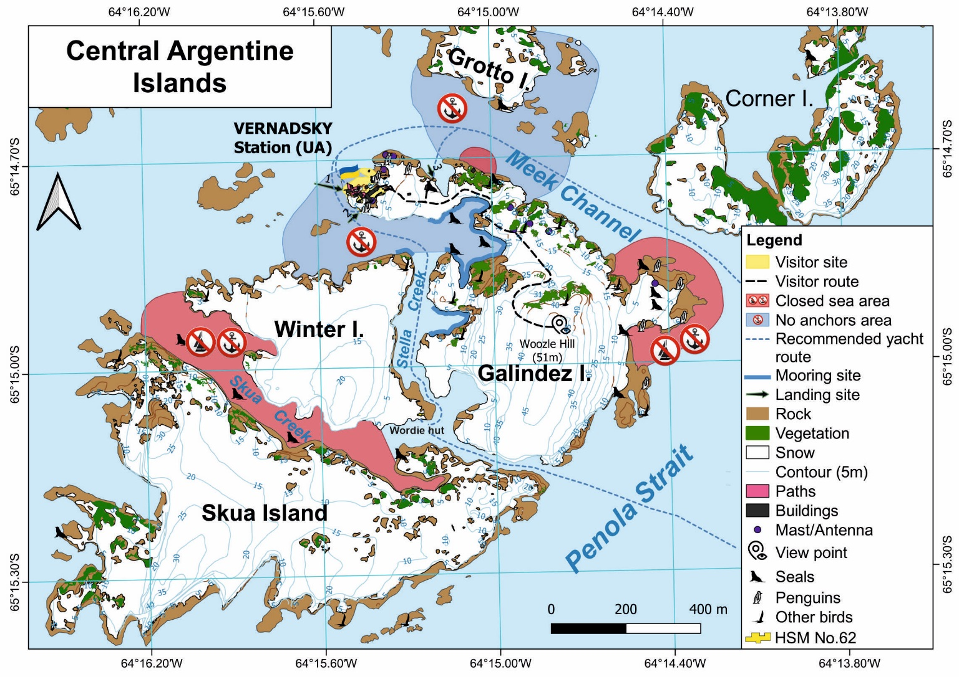
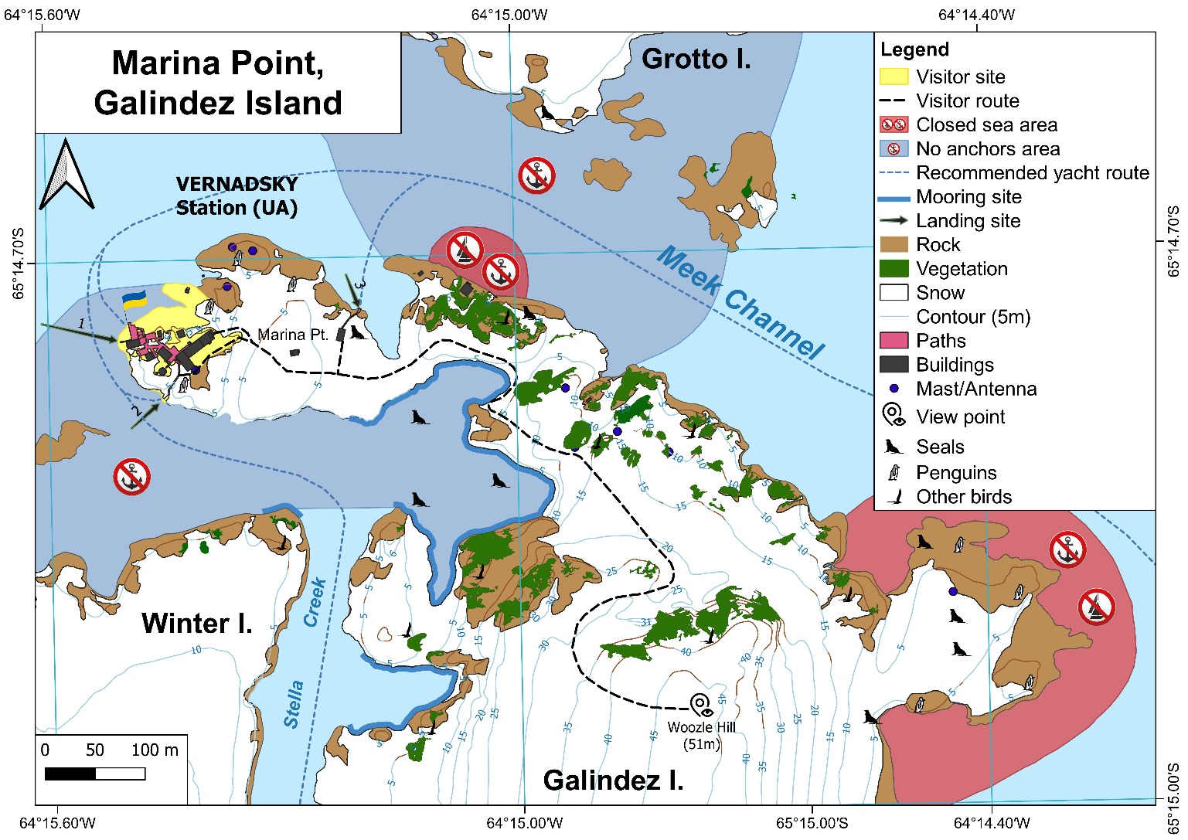

A yacht on the mooring site opposite the Vernadsky station
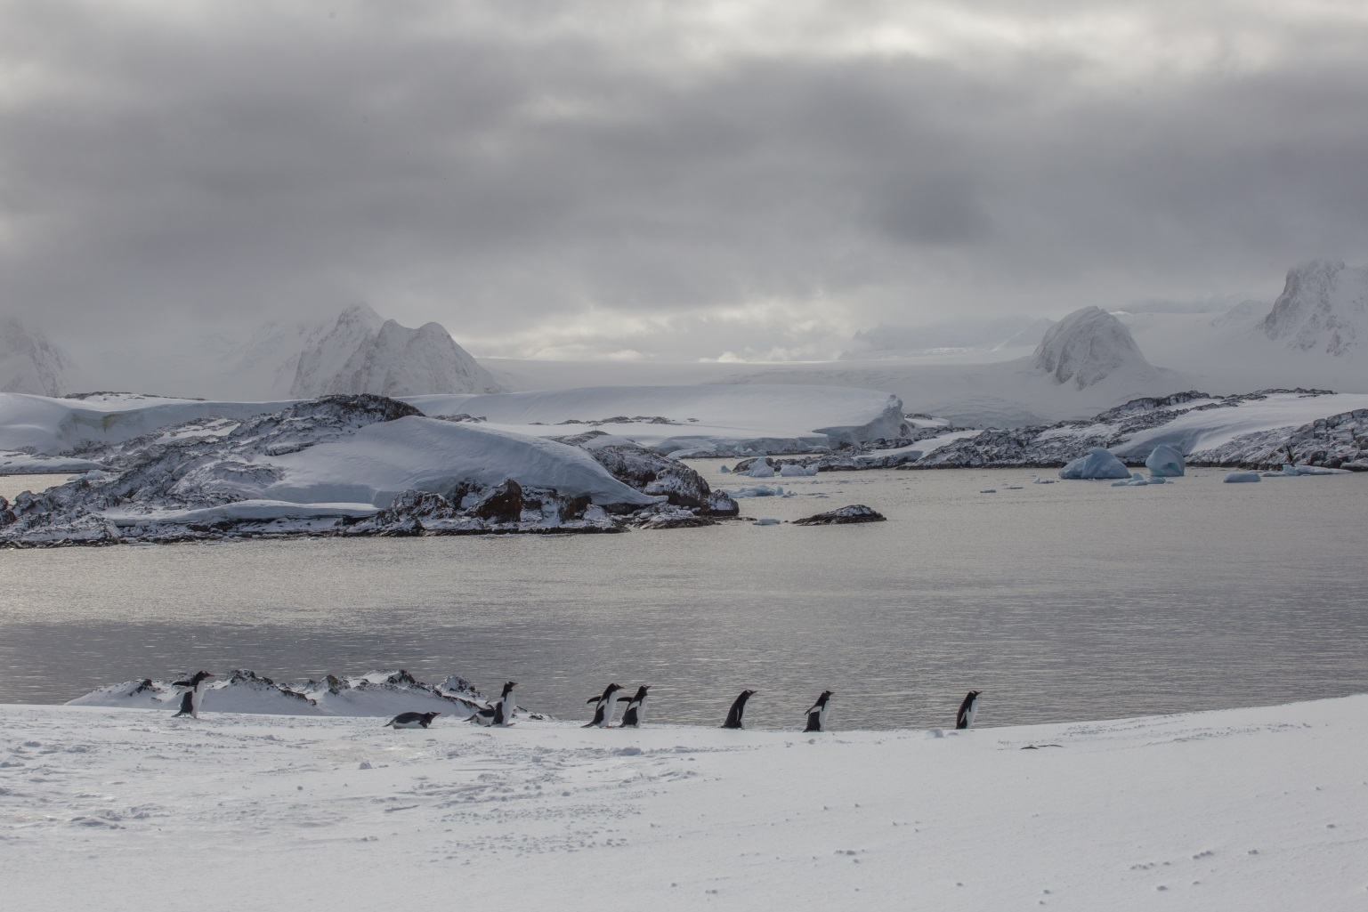
Gentoo penguins, with a scenic view of Antarctic Peninsula mountains in the background

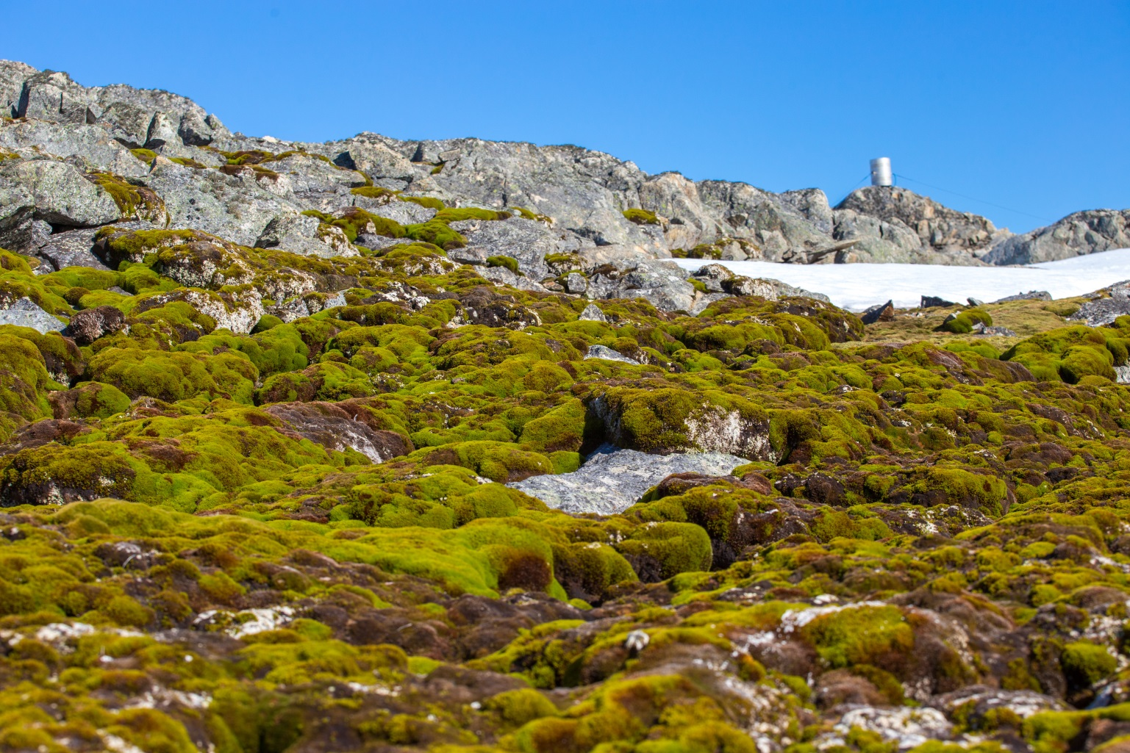
Moss banks at the foot of the Galindez ice cap
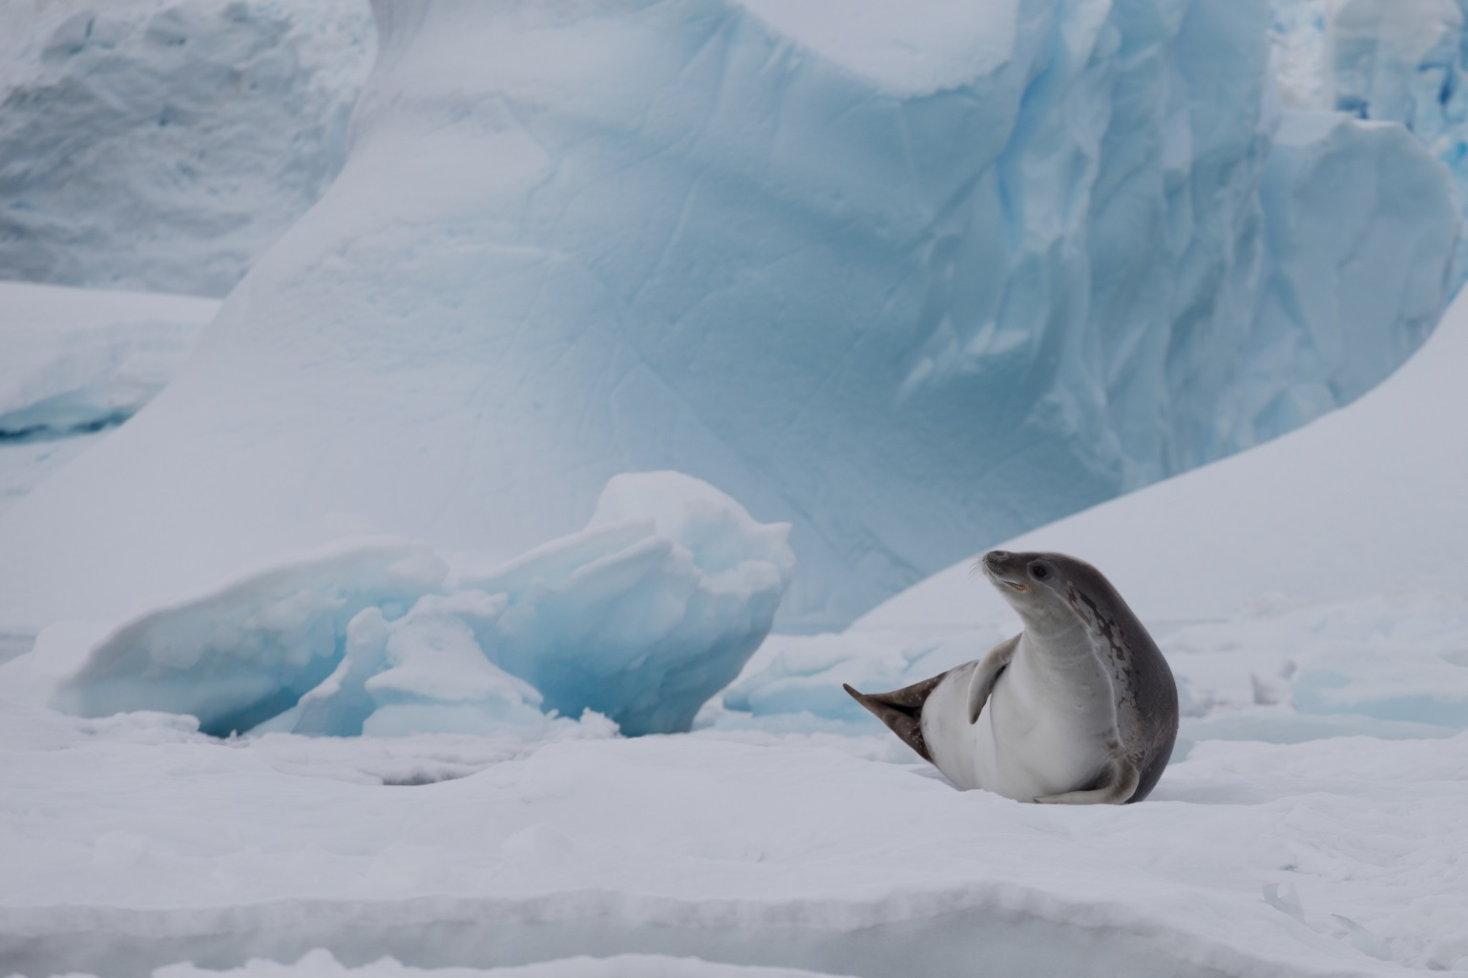
Crabeater seal resting on the ice

