Appendix A
No ___. Argentine Islands

65°15' 00'' S, 64°16' 00'' W
Group of islands in the Wilhelm Archipelago, separated from Graham Coast by Penola Strait

Key Features  - Year-round Vernadsky Station (Ukraine) and Historic British Base F, Wordie House  - Seal species and one of the southernmost recorded gentoo penguin colonies  - Populations of both species of vascular plants growing in Antarctica, mosses banks & lichens  - Glacial scenery | Area MAP to be inserted here

Description

TOPOGRAPHY
The group of three large islands in the Argentine Islands, lying 5-6 km NW of the Antarctic Peninsula (Graham Coast, Kiev Peninsula), e.g. Galindez (the largest one), Winter, and Skua. There are relict glaciers, post-glacier landforms such as moraines and glacier rocks, numerous rock outcrops, freshwater reservoires and ephemeral springs on the islands.
FAUNA
Confirmed breeders: gentoo penguin (Pygoscelis papua), south polar skua (Catharacta maccormicki), kelp gull (Larus dominicanus), Wilson’s storm petrel (Oceanites oceanicus).
Other birds: Adelie penguin (Pygoscelis adeliae), imperial shag (Phalacrocorax atriceps), snow petrel (Pagodroma nivea), southern fulmar (Fulmarus glacialoides), southern giant petrel (Macronectes giganteus), Antarctic petrel (Thalassoica antarctica), Antarctic tern (Sterna vittata), Arctic tern (Sterna paradisaea), brown skua (Stercorarius antarcticus).
Terrestrial invertebrates: Antarctic midge (Belgica antarctica), mites, water bears (Tardigrada sp.), springtails (Collembola sp.), nematodes , rotifers etc.
Regularly haul out: Weddell seal (Leptonychotes weddellii), Antarctic fur seal (Arctocephalus gazella).

Also visited by: southern elephant seal (Mirounga leonina).

On the pack-ice: crabeater seal (Lobodon carcinophaga) and leopard seal (Hydrurga leptonyx) (the latter also hunts near penguin colonies).
The waters are inhabited by many species of oceanic invertebrates and fishes.
FLORA
The islands are a botanical hotspot of the Antarctic Peninsula, hosting specific ornithogenic, populations of both native vascular plants Antarctic hair grass (Deschampsia antarctica E. Desv) and rare Antarctic pearlwort (Colobanthus quitensis (Kunth.), fruticose lichen and moss cushion subformations, crustose lichens, moss carpets and valuable communities of ancient moss turf sub-formations (moss banks up to 3800 y.o.), algae and snow algae formations.
In the whole Argentine Islands area, the region is the only currently known location of the lichen Himantormia lugubris (Hue) M. Lamb.

OTHER
The year-round Vernadsky Station (Ukraine) is situated in the NW of the Galindez Island, on the Marina Point. The Historic British Base F (Wordie House) on the Winter Island is designated as an Historic Site and Monument No. 62 under the Antarctic Treaty.

CCAMLR Environmental Monitoring Program (CEMP) sites, managed by Ukraine, are located on Galindez Island (see map). The gentoo penguins are monitored for population size and breeding success.
Visitor Impact

KNOWN IMPACT
Trampling of vegetation, especially moss banks and lichens.
POTENCIAL IMPACT
Disturbance of nesting sea birds and mammals, including underwater wildlife (while yachts anchoring). Disturbance of monitoring program sites.
Landing requirements
SHIPS* and yachts**

Maximum visitors per day: 270
Maximum ships per week: 2
Yachts per day: 3
No more than 30 visitors ashore or inside the station at any time, exclusive of expedition guides and leaders.

Comments:
The above mentioned restrictions apply in case of visiting Vernadsky Station (Ukraine), while yachting and small boat cruising without landing within the internal waters of the Argentine Islands are not restricted. Also see the landing requirements for ships specified by the Visitor Guidelines for the Winter Island (Resolution 1 (2010).
Tour vessels and yachts visiting the area should provide advance notice of their visit schedule to National Programs operating in the area, in particular to Vernadsky Station Leader. Priority is given to vessels supporting science activities.
For the safety of marine mammals, the speed limit within the coastal waters of Argentine Islands is 7 km/hr. Yachts and small boats cruising should avoid disturbing seal and bird colonies and should keep the distance of approximately 30 m from the Closed sea areas. Tour vessels are forbidden to entry/pass through or anchor in the Closed sea areas, except the part of the Meek Channel between Galindez Island and Grotto Island where only scientific and supply vessels are allowed to anchor.

anchorage
Tour vessels visiting the Argentine Islands should lie at a safe distance in Penola Strait or French Passage, while visitors are sent ashore by small boats through Meek Channel, using either a basic anchor zone in Stella Creek or an auxiliary anchor zone in Meek Channel, mostly accessible during the NW wind (see map).

Breaking ice to steer a vessel or a boats is forbidden within the internal waters of the Argentine Islands in order to accommodate resting crabeaters.

Mooring
Mooring is permitted in specially equipped places and only within the coastal strip marked on the map as «mooring site». Yachts can be tied up to the mooring steel poles on the shore.

Vessels moor at their discretion within the permitted zones. The Vernadsky Station personnel is not responsible for possible damages to vessels or passengers caused by improper choice of anchorage/mooring place or bad weather.

* A ship is defined as a vessel which carries more than 12 passengers.
** A yacht is defined as a vessel that carries up to 12 passеngers.

VISITORS
Visitors are divided into groups; total number of people on each landing point or tourist route simultaneously should not be more than 36, not including staff and station guides.

Curfew time period (from/to), in order to establish a rest period for wildlife: 22:00-04:00.

Visitors enter in this area at their own risk, and neither the personnel from Vernadsky Station, nor the National Antarctic Scientific Centre, nor the Ukraine authorities will be liable for any personal injury or damage to property that may be sustained while they stay within the area.

Visitor Area

LANDING AREA

Depending on the sea ice, snow coverage conditions and the working schedule of the Vernadsky Station, there are several landing sites marked on the map as follows:

Galindez Island: main landing site (1), additional landing site (2), reserve landing site (3).

Winter Island: on the SE side of the island, directly in front of Wordie House (see map).
GUIDED WALKING AREA
There are two recommended tourist routes within the Argentine Islands.
On the Galindez Island – from Vernadsky Station on Marina Point to the emergency base and further along old buildings (aerology hut, precipitation gauge etc.) to the top of the ice cap called Woozle Hill (51 m);
On the Winter Island: from the Historic Site Wordie House on the SE side of the island to the top of -the ice cap.
It is forbidden to deviate from the tourist route and to approach the scientific objects along it, as well as to step on rocks covered with mosses.

FREE ROAMING AREA
No free roaming area. Due to the uneven landscape and cliffs, visitors are forbidden to roam unaccompanied by guide supervisors or to deviate from the tourist routes.

CLOSED AREA*
To preserve the terrestrial (rich moss and lichen vegetation, initial soils, and nesting areas) and sea biodiversity, all areas not specifically designated to tourist activities are closed for them. Special attention should be paid to the closed waters between the islands.
* These rules also apply to the Vernadsky Station personnel and other members of the National Antarctic programs who visit the Argentine Islands with recreational purposes.
Visitor code of conduct
BEHAVIOUR ASHORE
- All visits are to follow the General Guidelines for Visitors to the Antarctic (Resolution 3 (2011)) and the Yachting guidelines for Antarctic cruises (Resolution 10 (2012)).
- Visits to Vernadsky Station are to follow the Ukraine policy regarding visits by tourists to Vernadsky Station (ATCM XXXIV IP-110 with the attachment).
- Visits to the Historic Site Base F (‘Wordie House’) are to follow the Visitor Guidelines for the Winter Island (Resolution 1 (2010)).
- While using tourist routes ensure visitors are guided.
- Do not walk on any vegetation. Do not collect of fossils, plants, mosses, shells, also do not chip ice from the glaciers.
- Avoid disrupting penguin routes to and from the sea. Always give animals the right-of-way.
- Visitors should not touch scientific equipment, especially cameras observing the penguin colonies, since it can distort the records.
Comments:
Visits should always be kept to areas where the snow is thick enough to avoid damage to the vegetation, particularly moss and lichen, which is abundant across all exposed rock and boulder areas.
Small boat cruising is an appropriate alternative to landing at this site, particularly late in the season when snow has melted exposing more vegetation.

CAUTIONARY NOTES
Please be tolerant and don’t disturb wild animals and birds that can approach a closed area’s border. Keep a distance of at least 10m from them, especially if you meet big mammals: seals, sea elephants and sea leopards can harm a human if scared.
Many small bays indented in the Argentine Islands coastline are convenient for yacht anchorage, especially when bad weather. However, small boat drivers should be aware of submerged rocks and foul waters between Skua and Galindez Islands. Compacted snow and ice around the coastline can be undercut by sea water and result in overhangs, which can be dangerous.

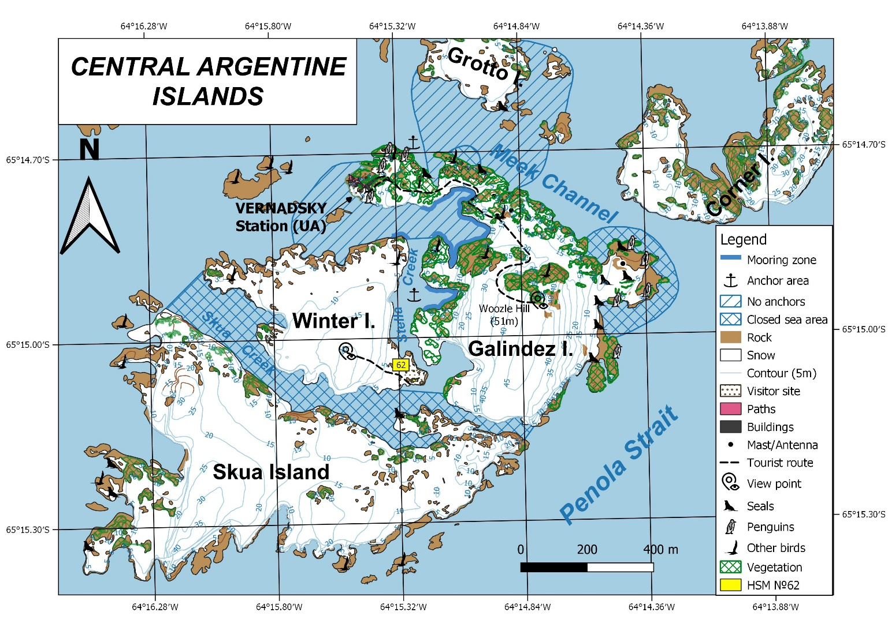

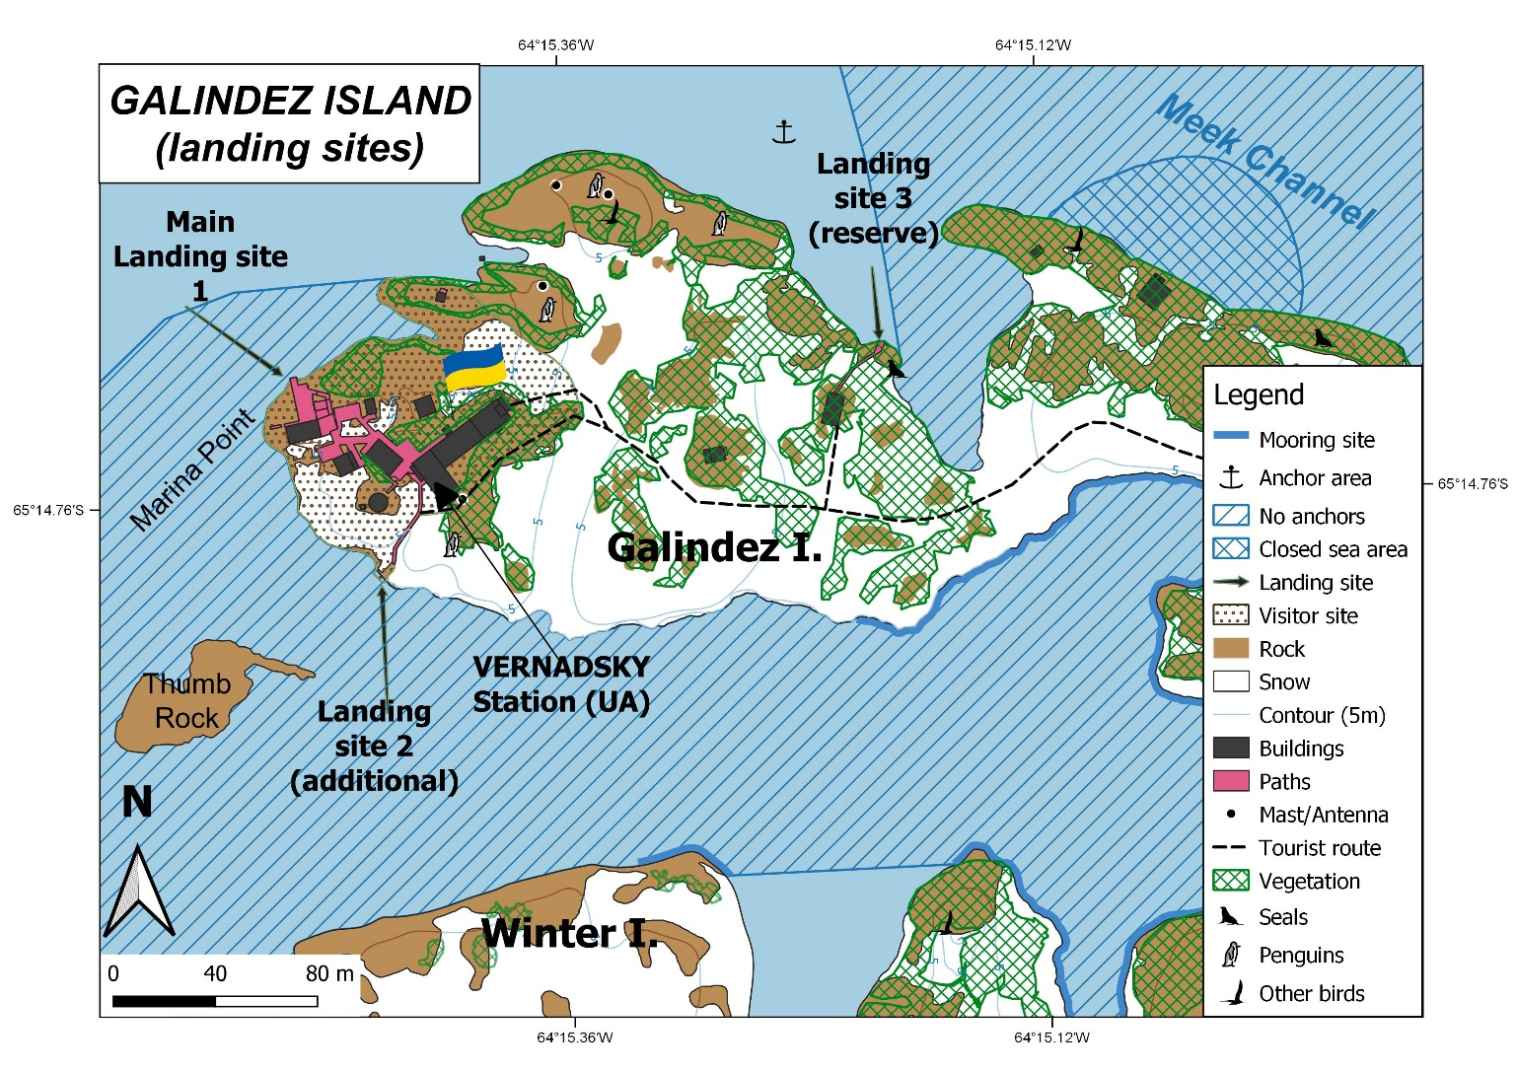

A yacht on the mooring site opposite the Vernadsky station
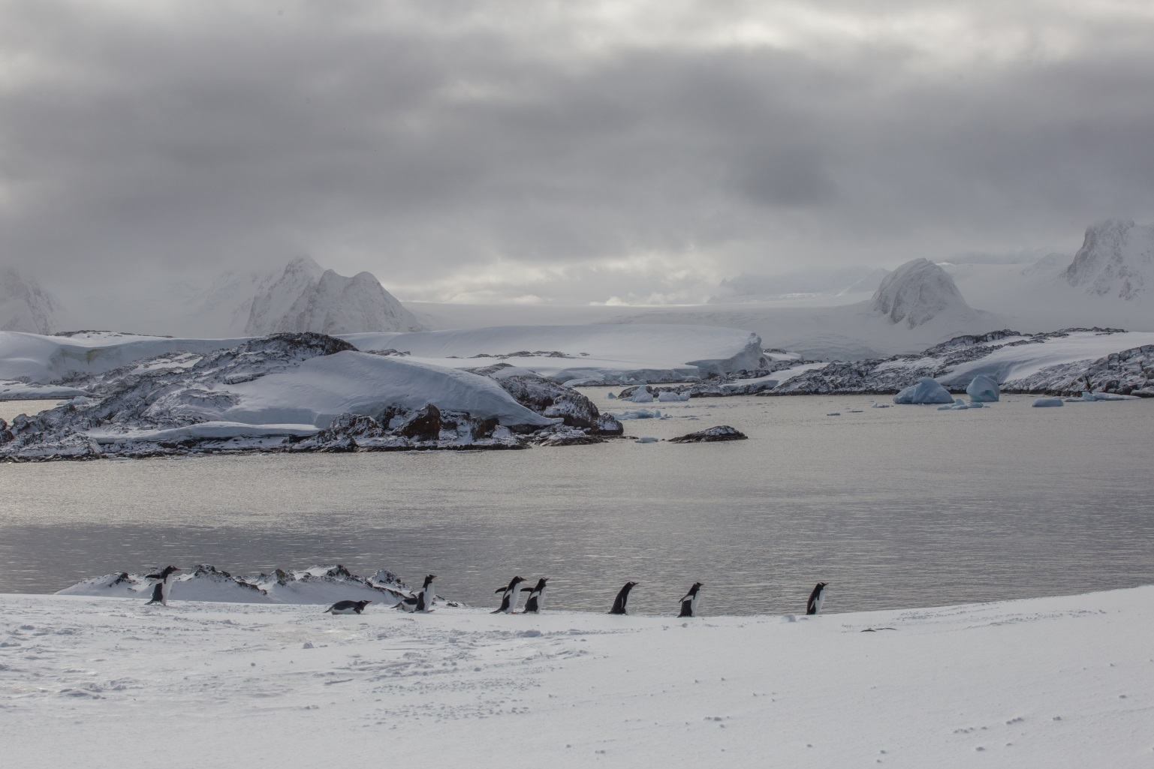
Gentoo penguins, with a scenic view of Antarctic Peninsula mountains in the background

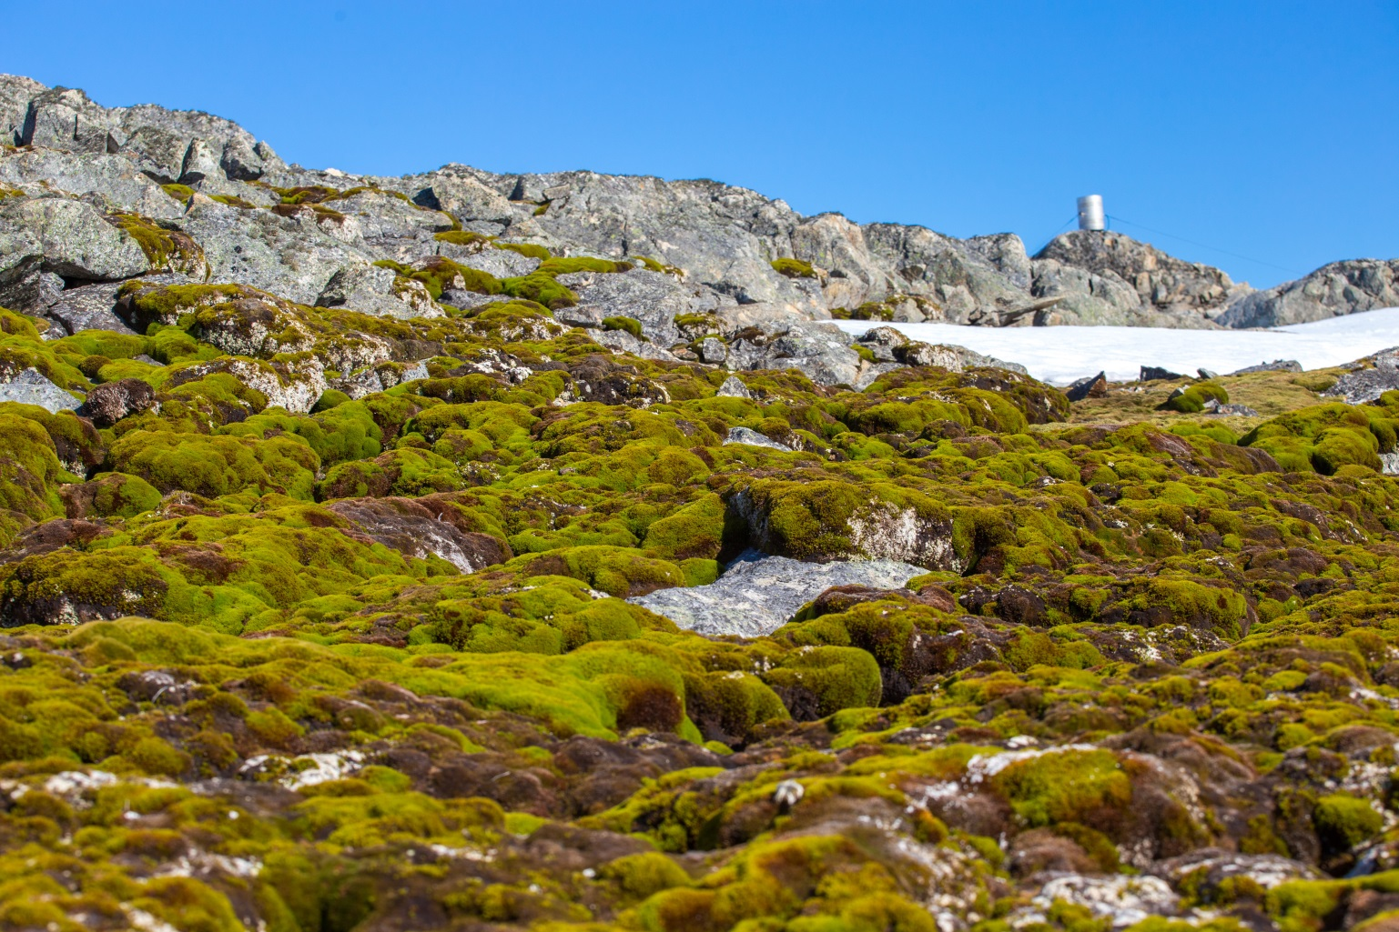
Moss banks at the foot of the Galindez ice cap
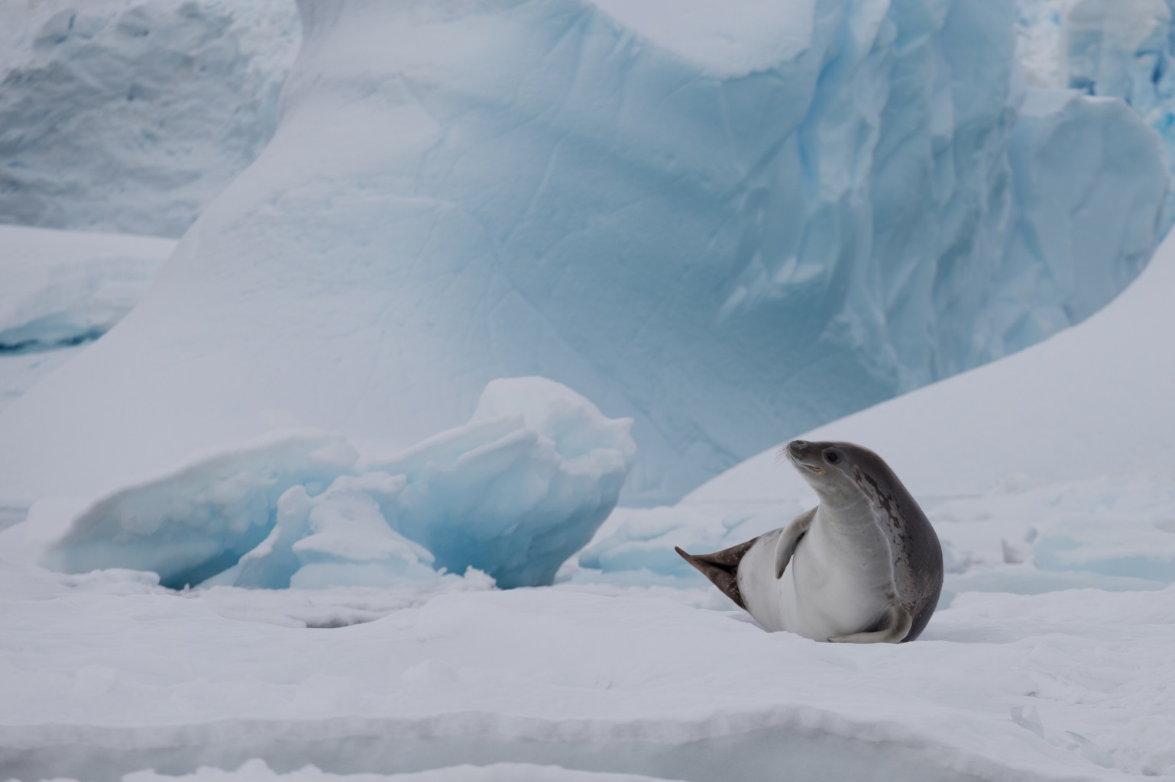
Crabeater seal resting on the ice
All photos from the NASC archive

